To make an empty array in swift:

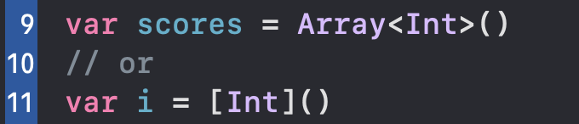

To append:

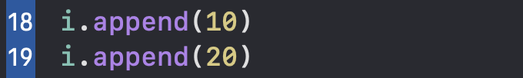

// it is just like in python

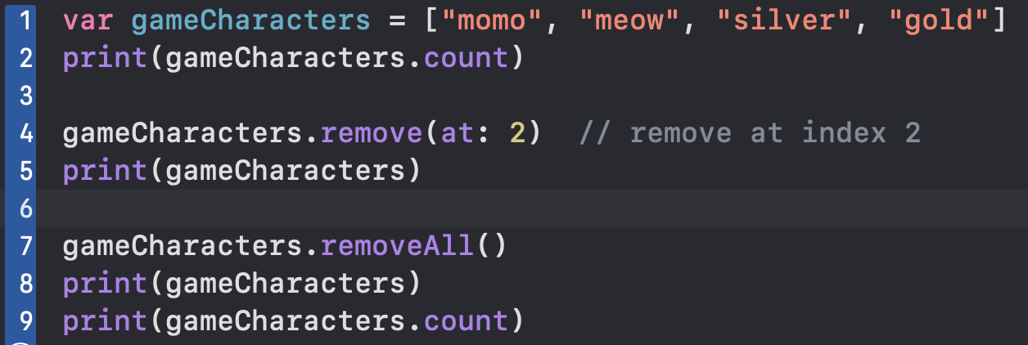



Dictionary

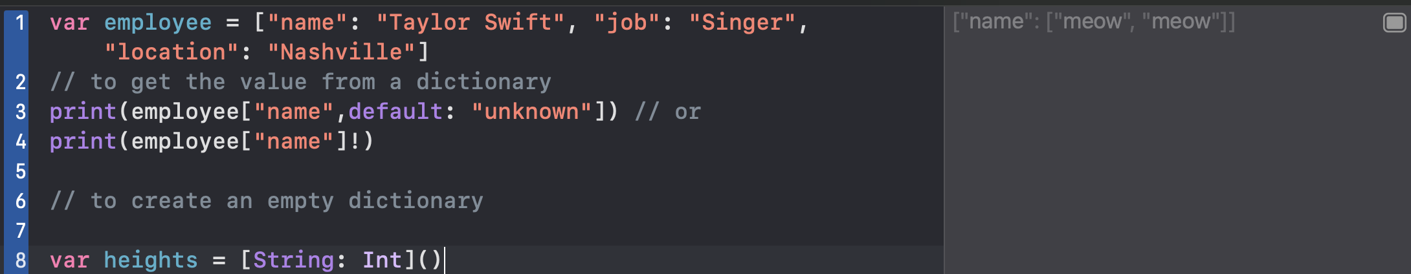

A set like an array. Set will remove all duplicated values in the array; set don’t use the concept of index; it is like set in python

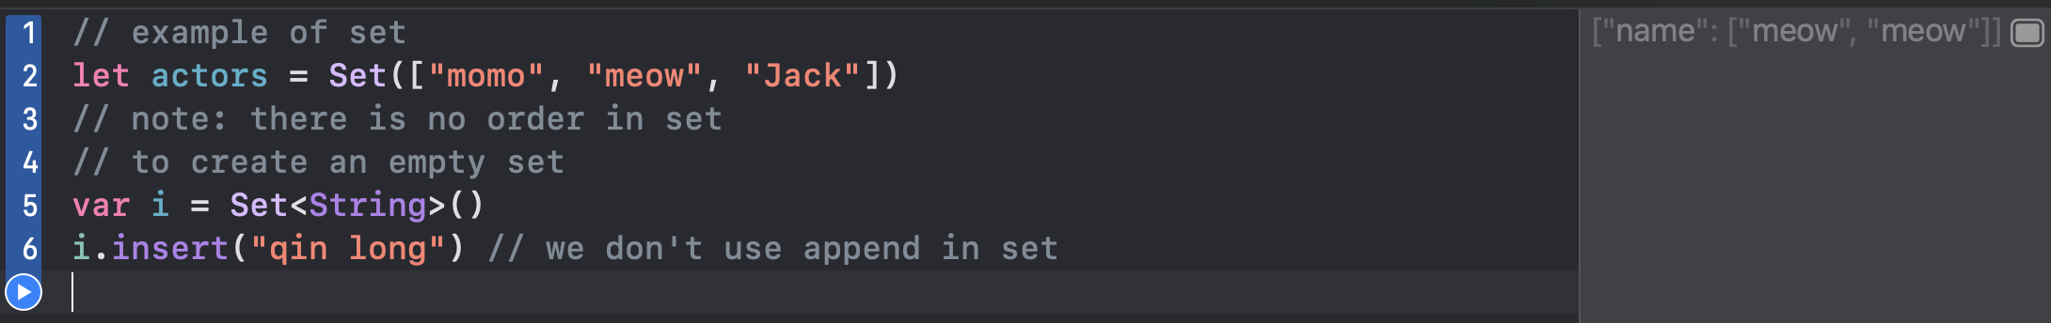

Enumerate

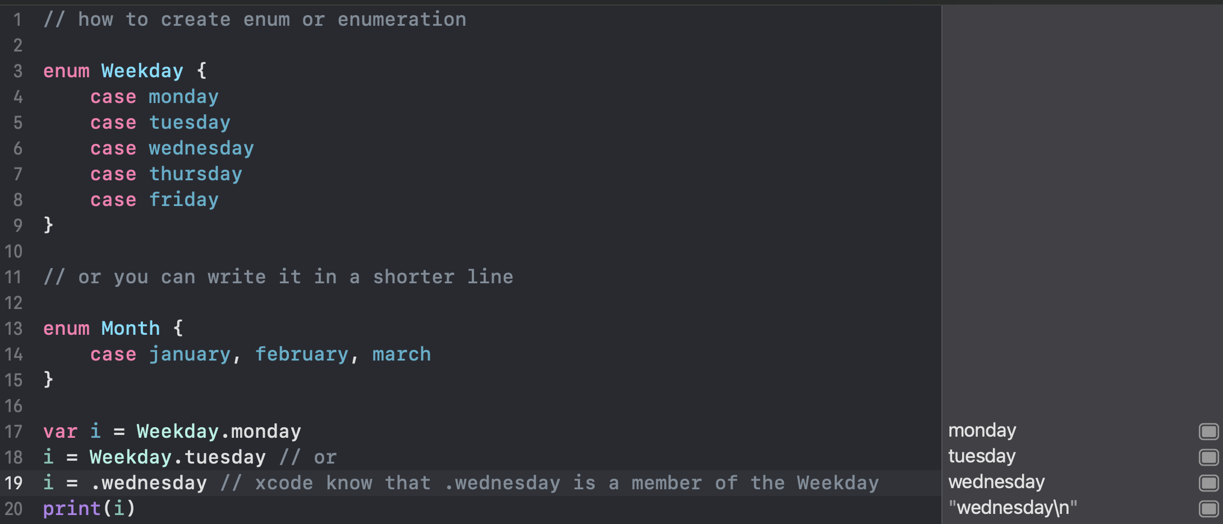

How to use type annotations

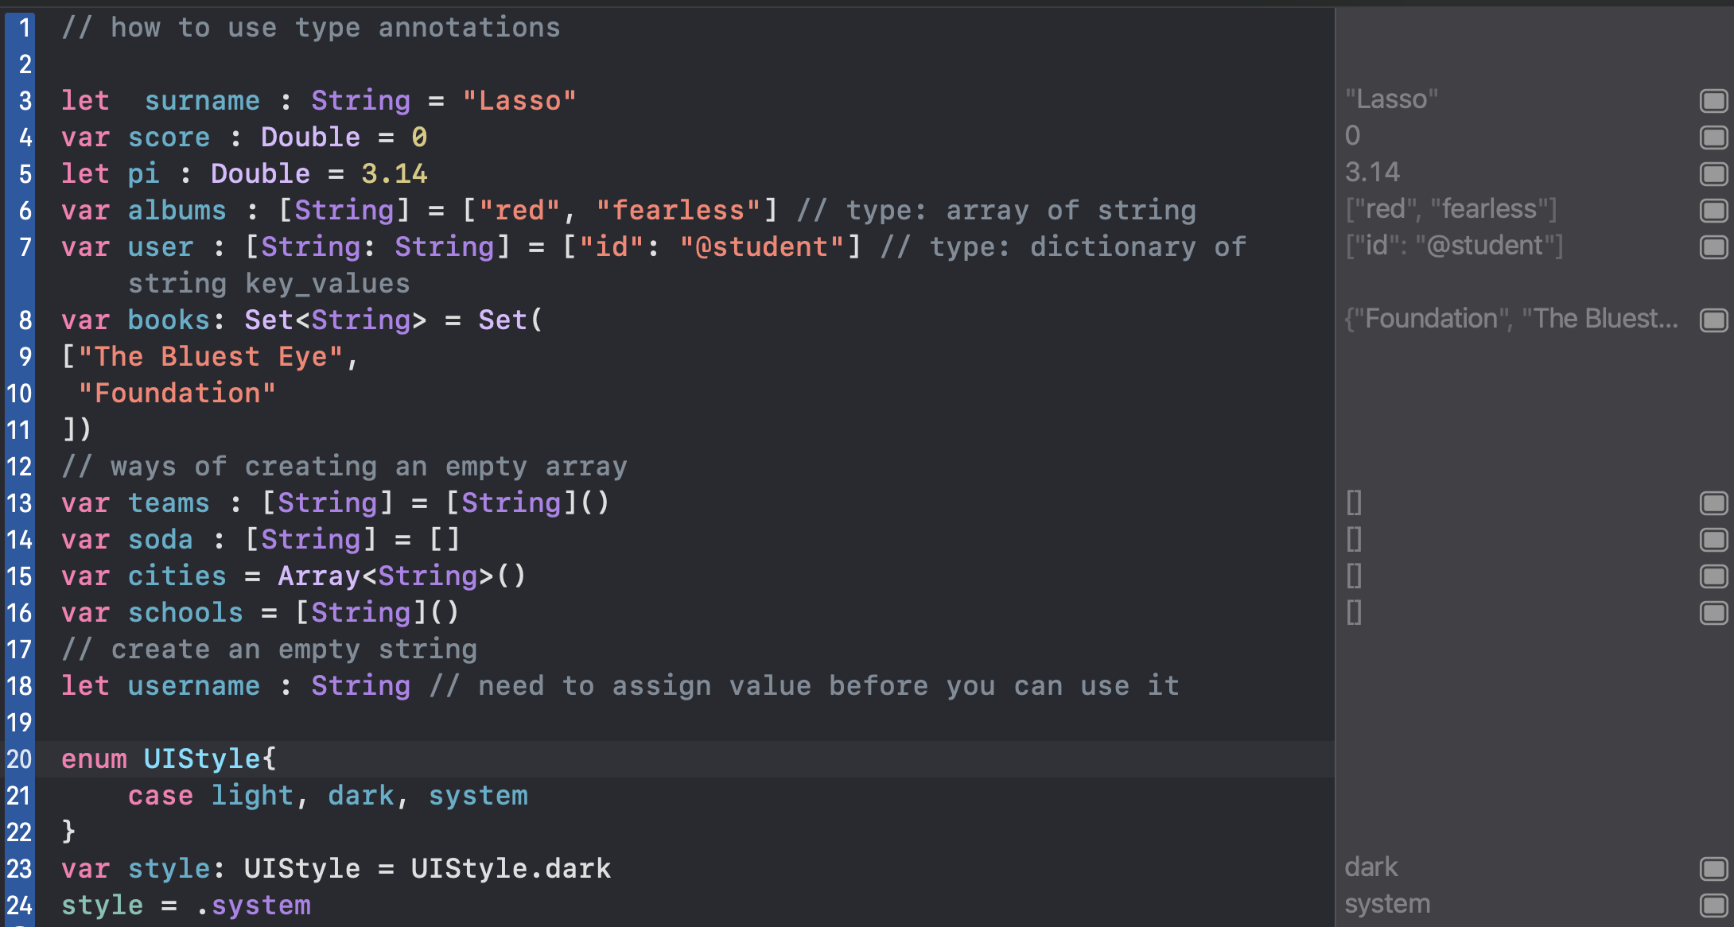

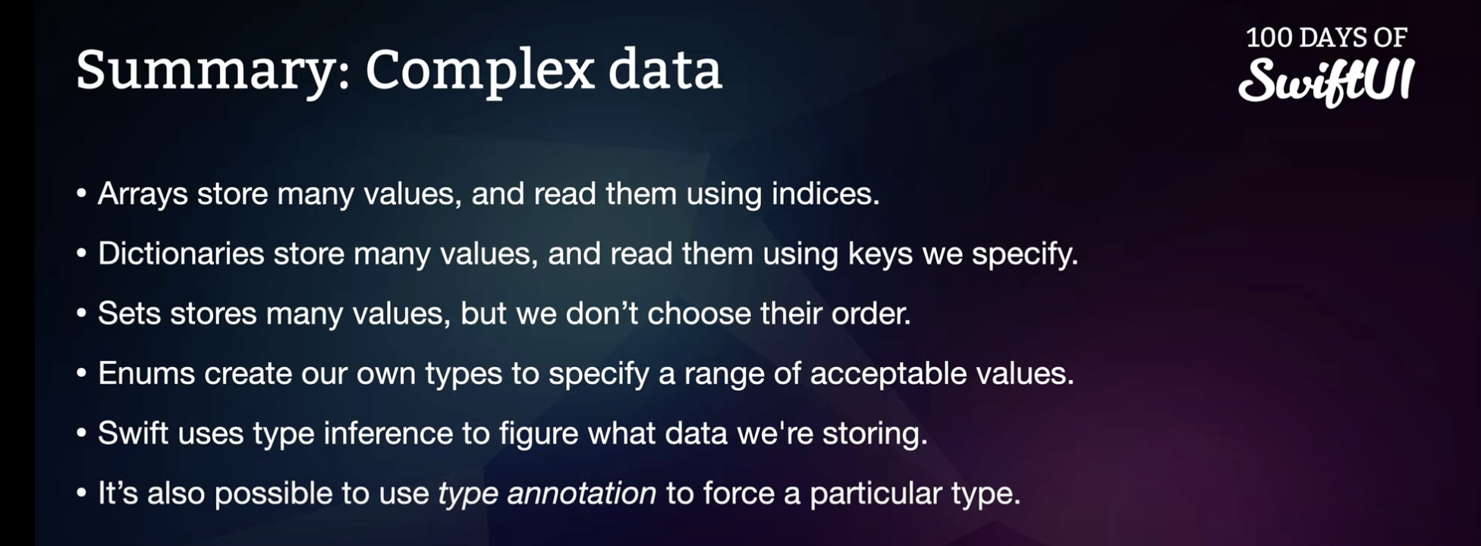

Conditional statement

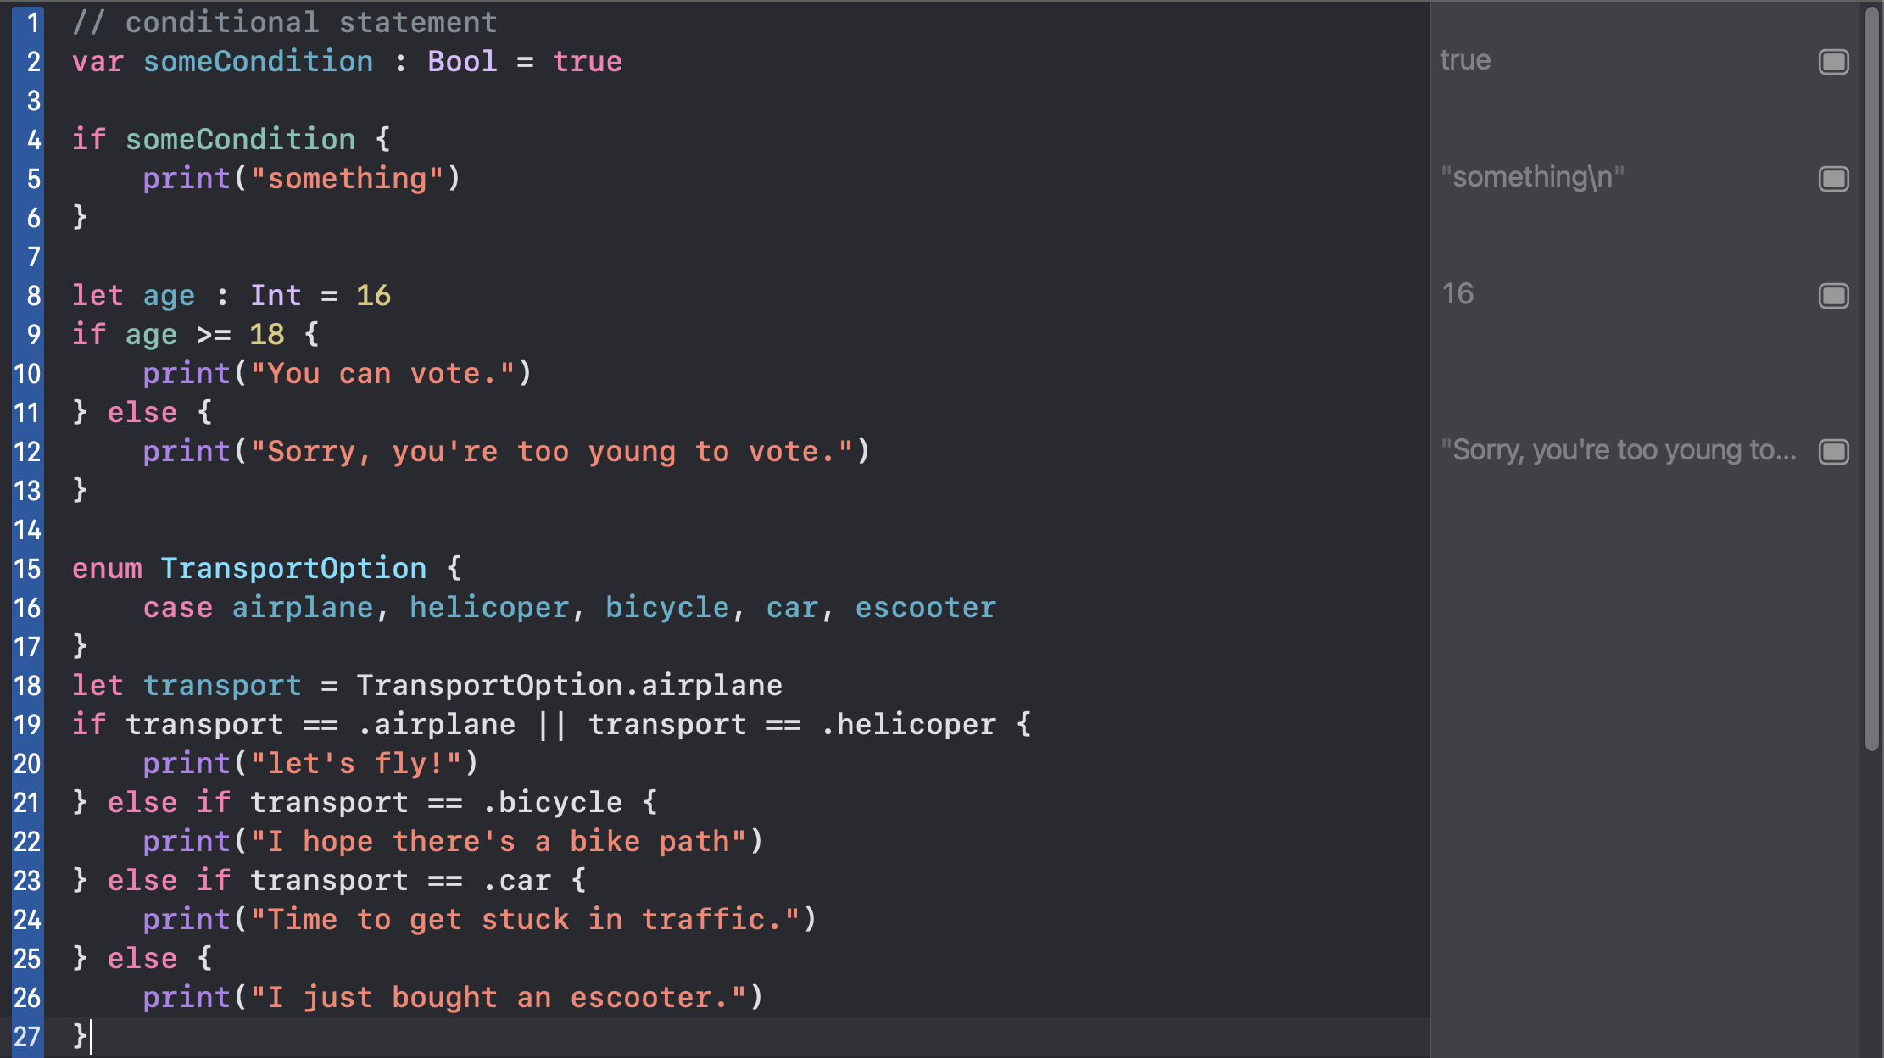

How to use switch statements to check multiple conditions

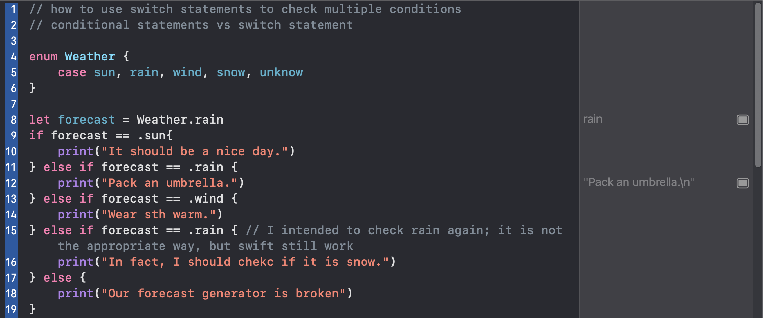

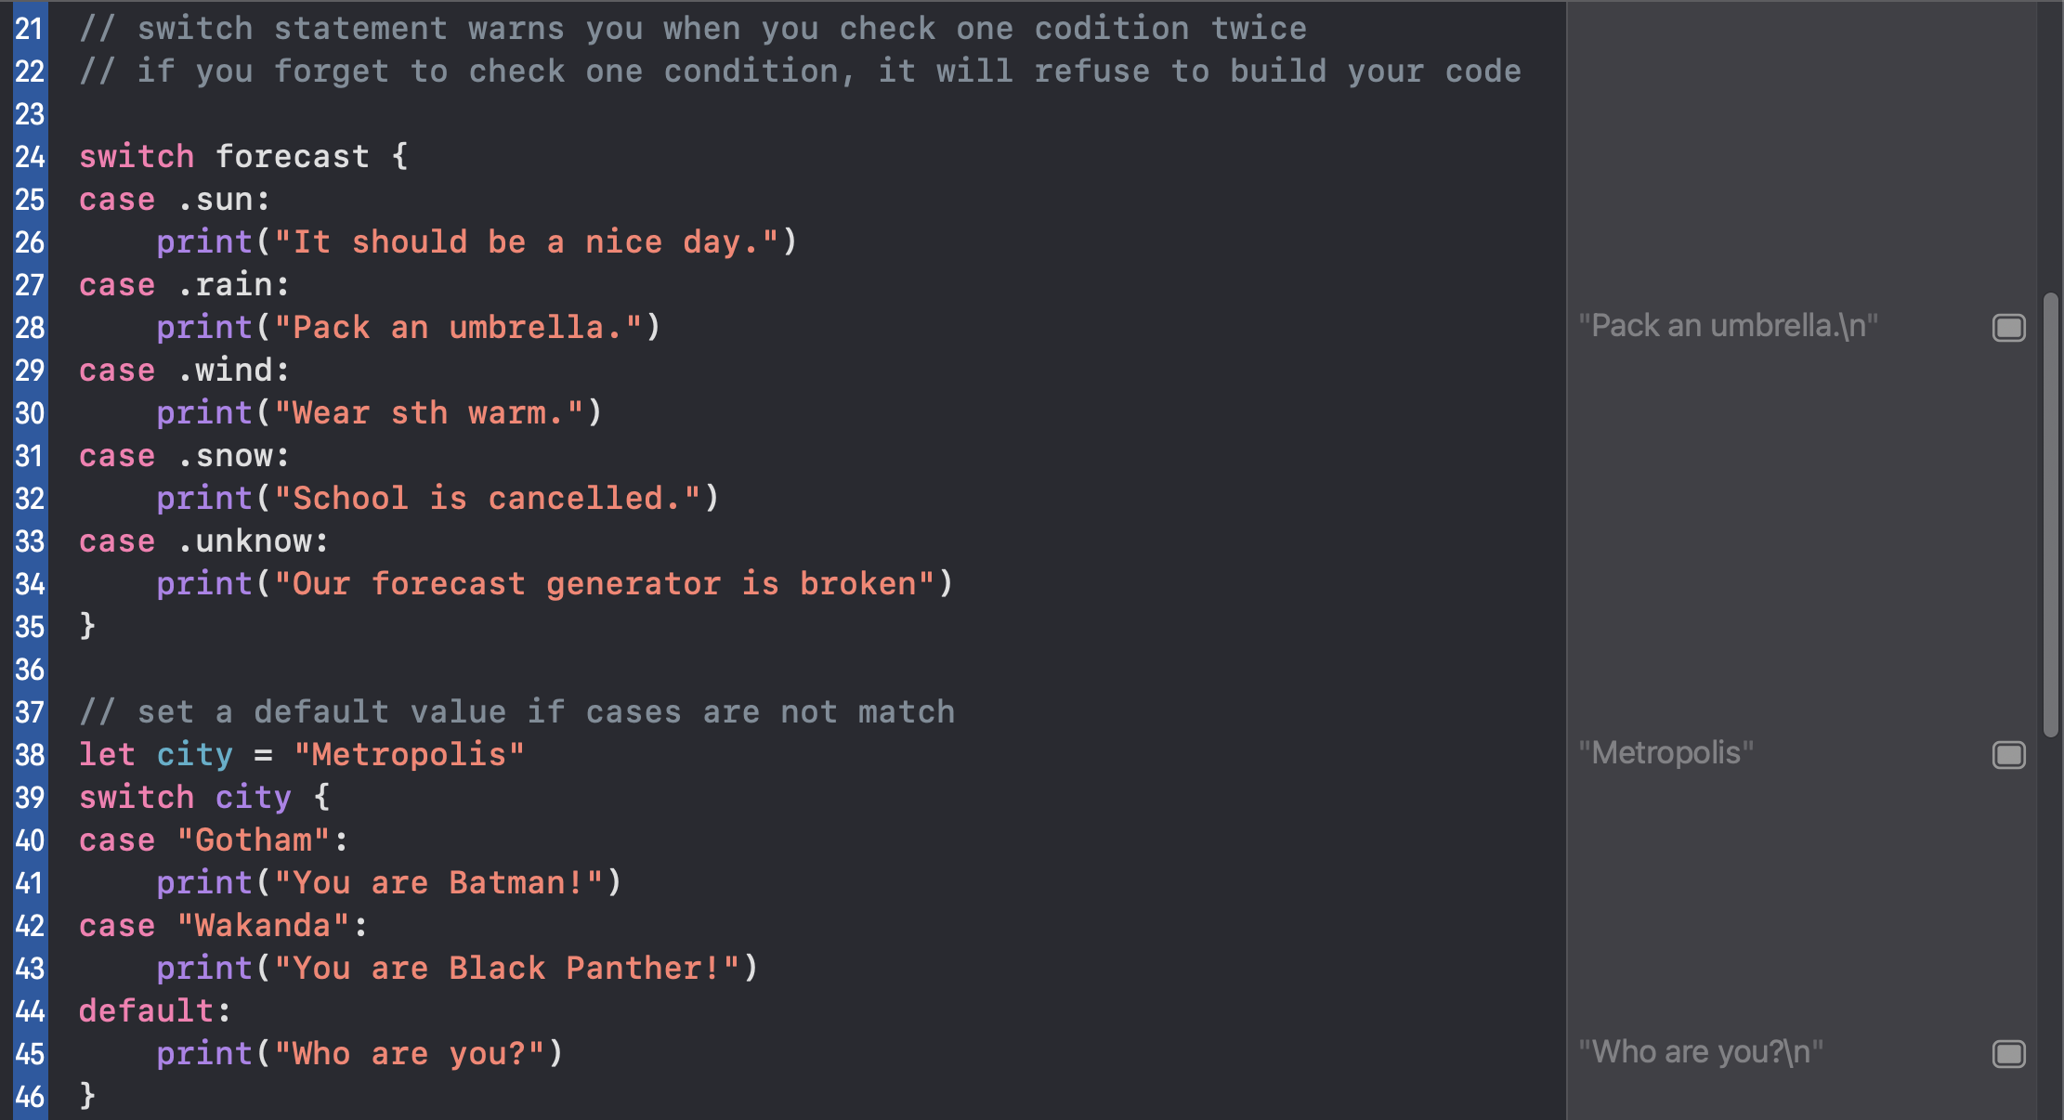

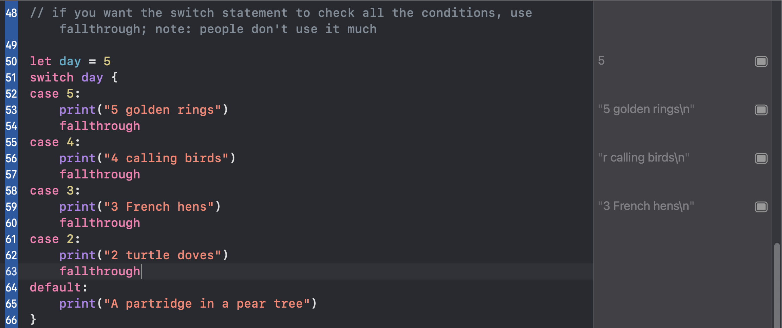

Ternary Operator

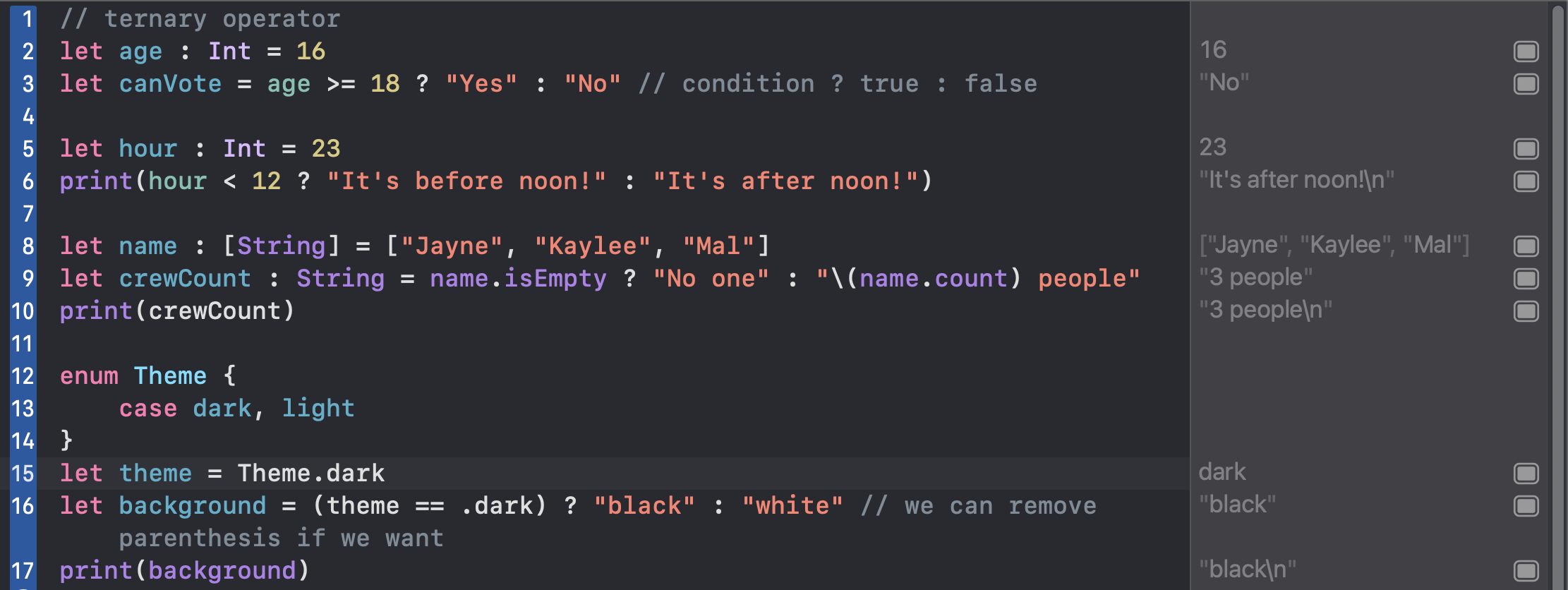

For loop

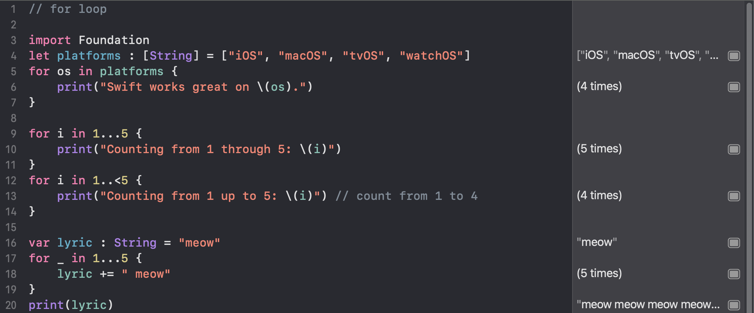

While loop

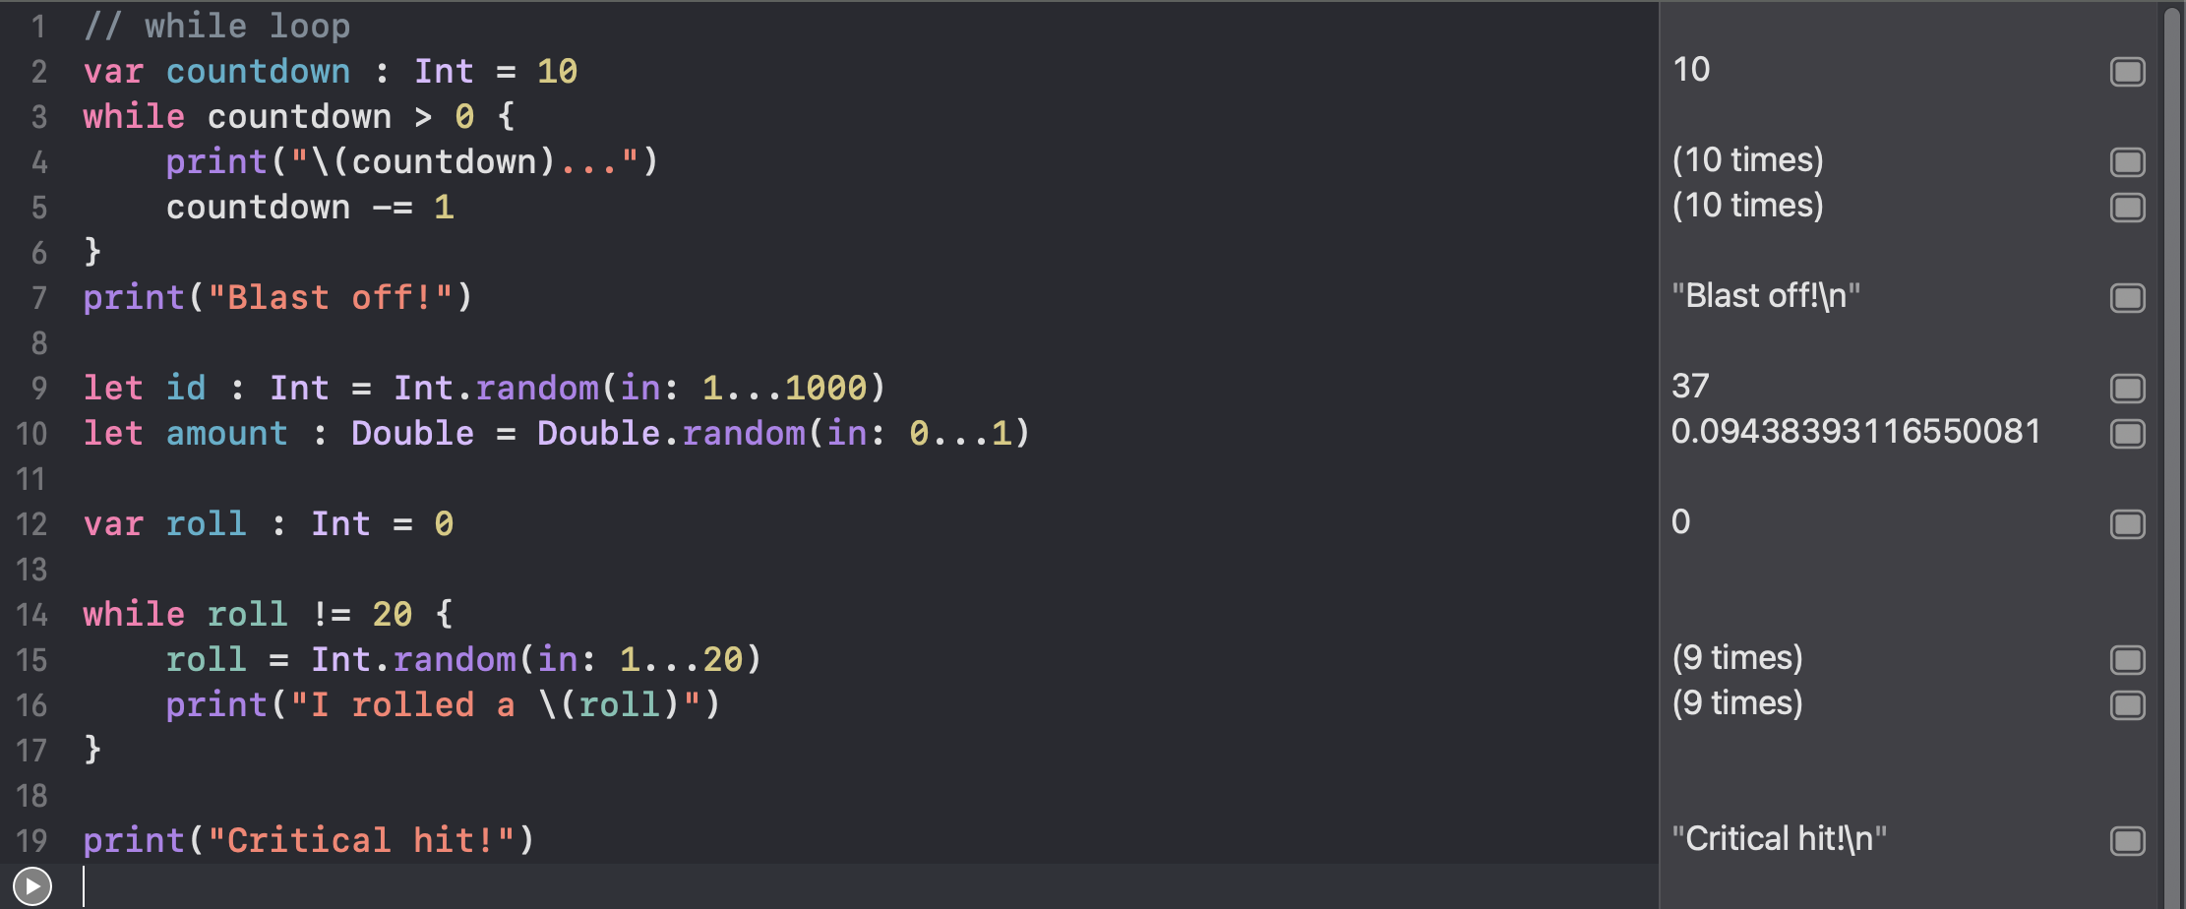

Function

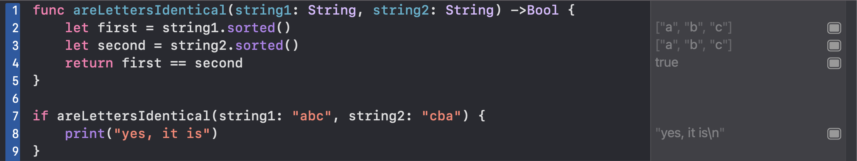

Function that returns tuple

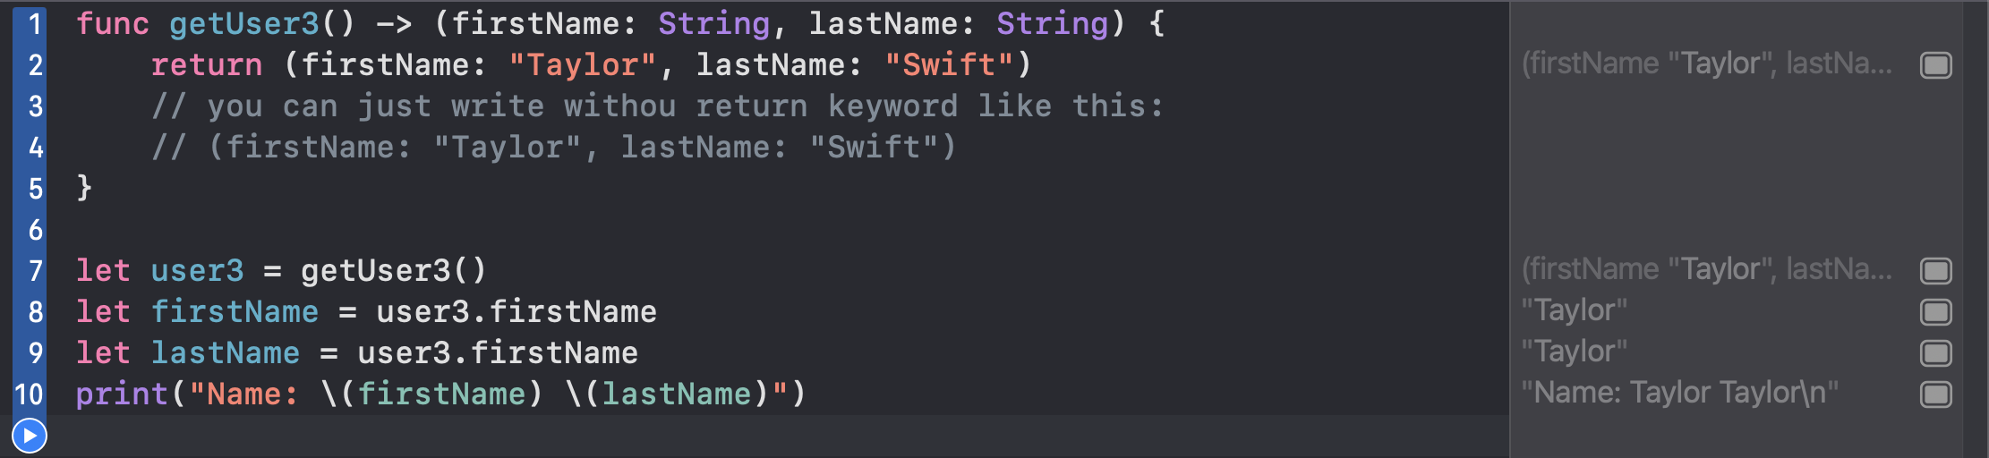

Or

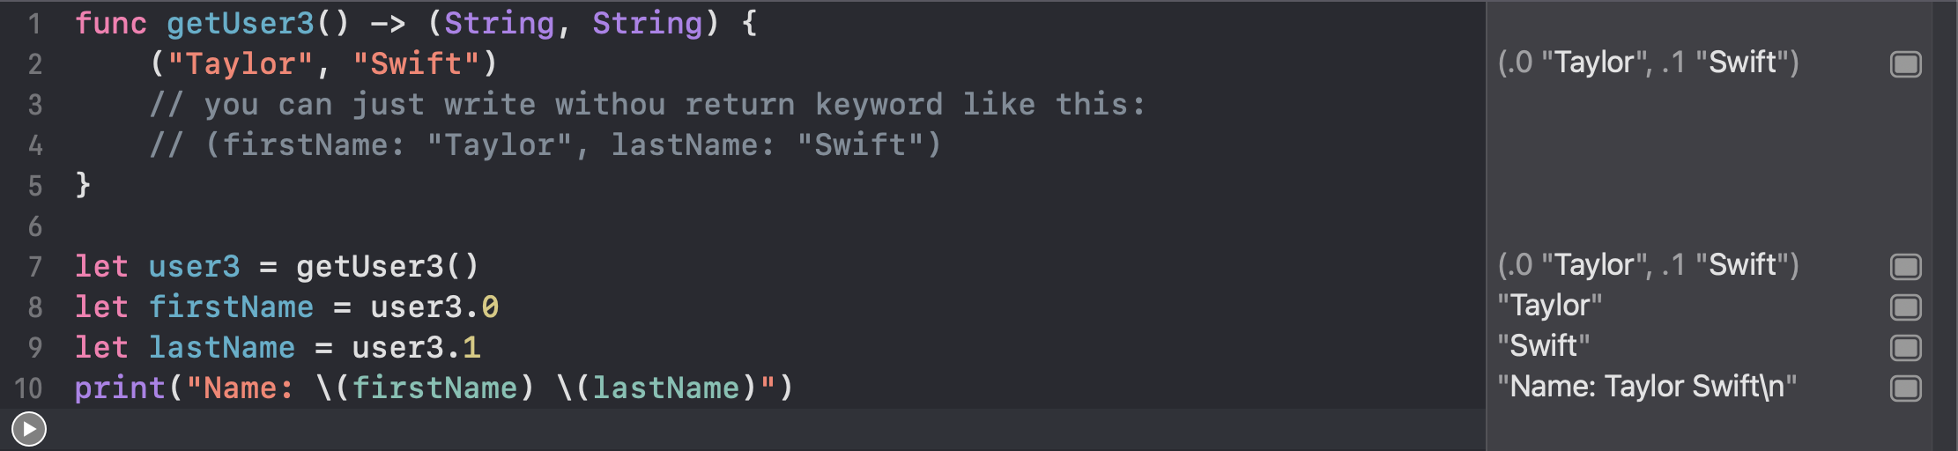

Or

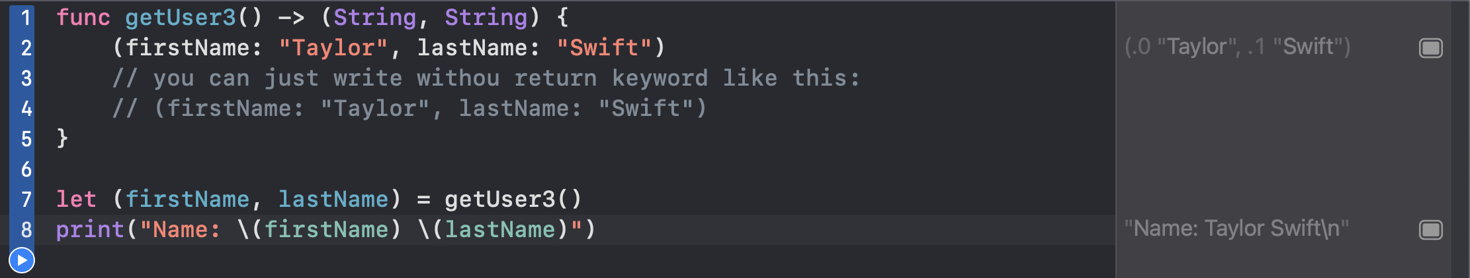

Internal vs external argument

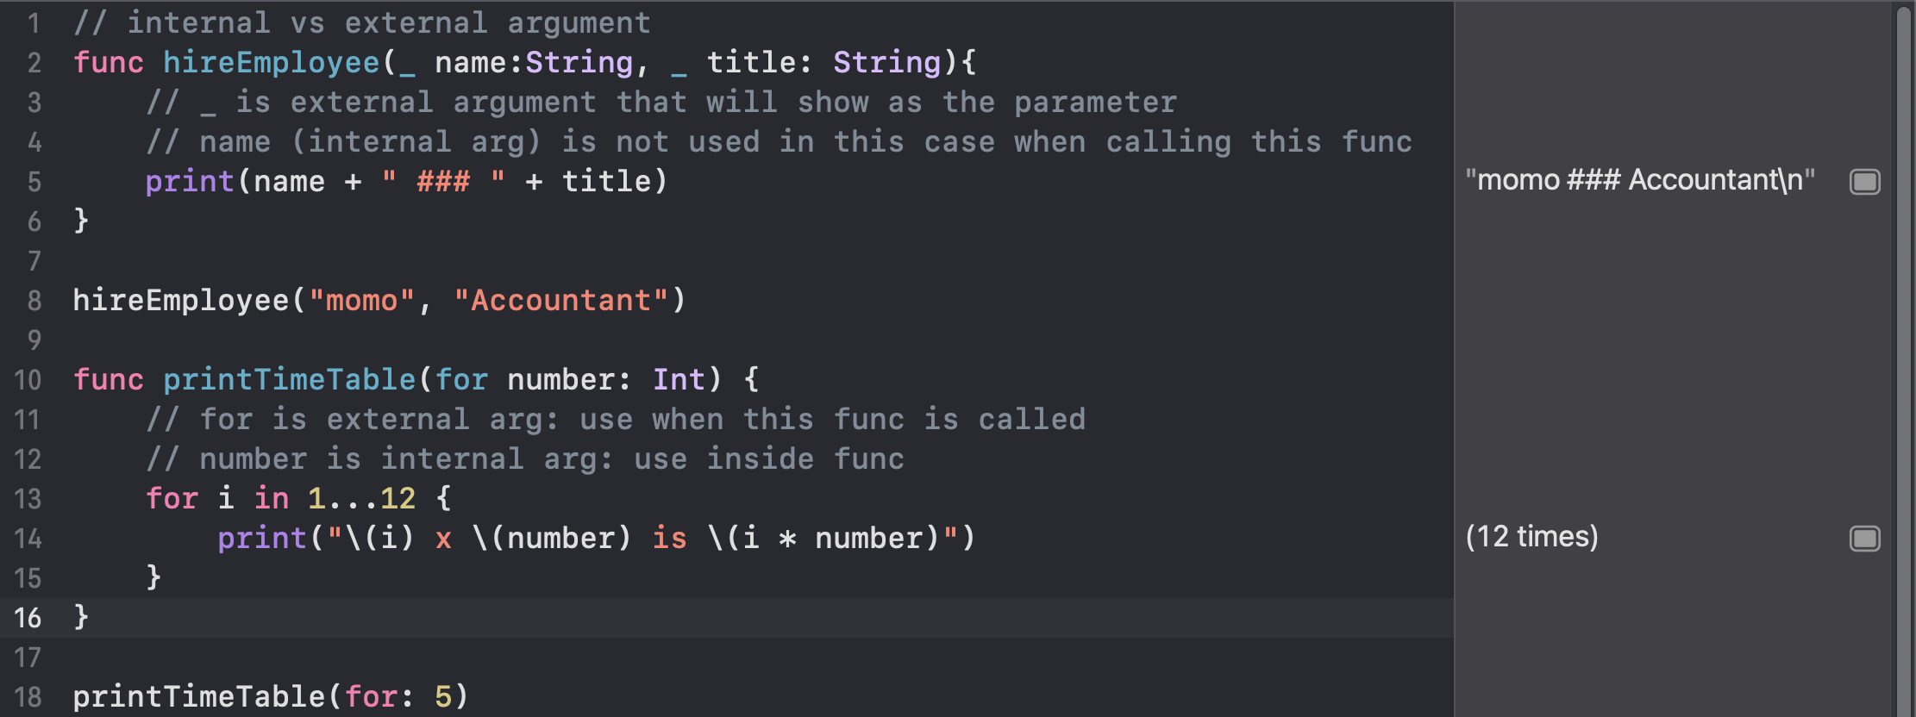

// How to provide default values for parameters

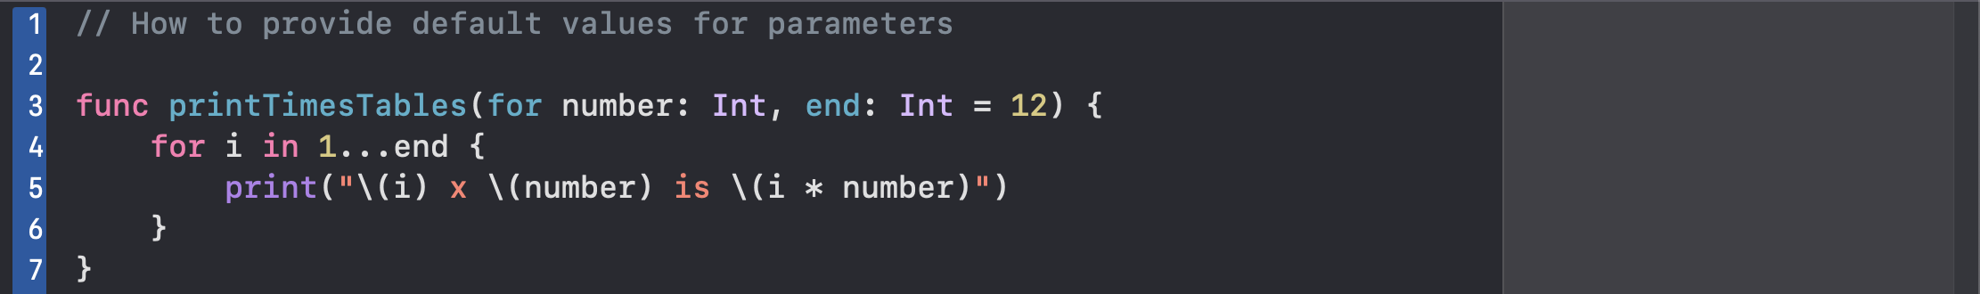

// Errors handling

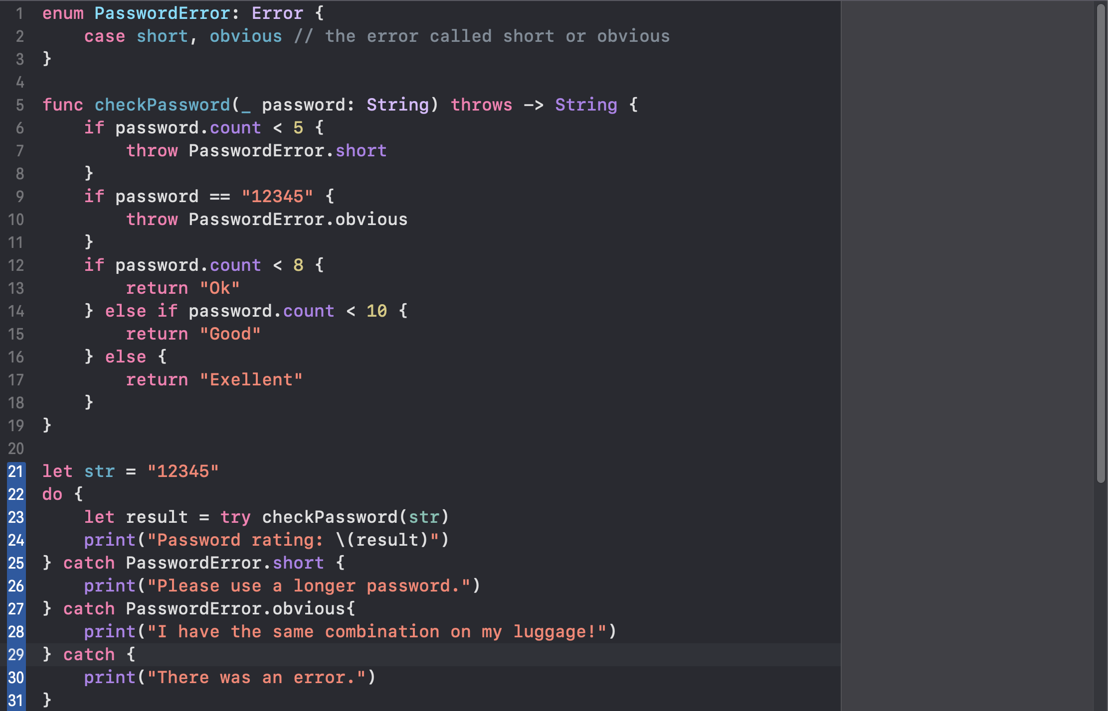

// Pseudocodes

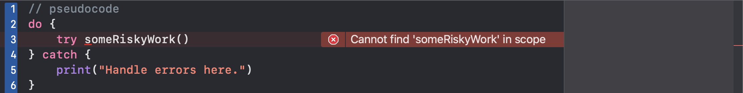

Copy function

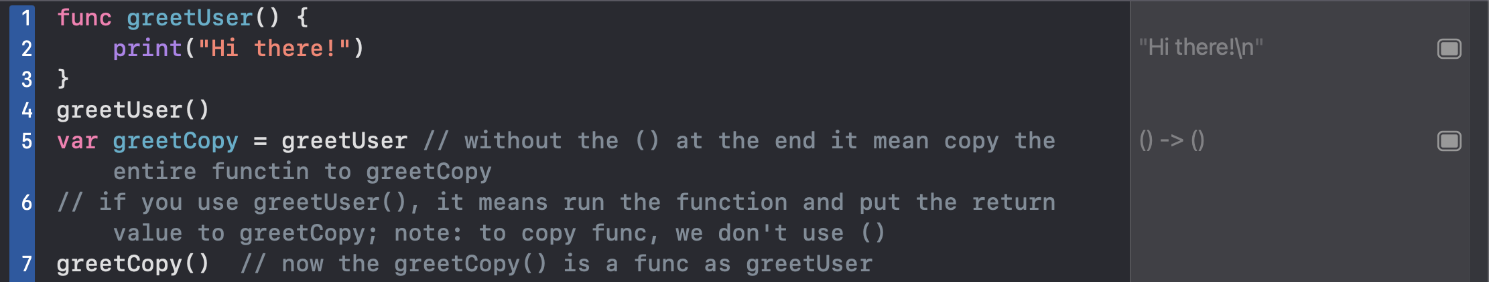

Function as a datatype

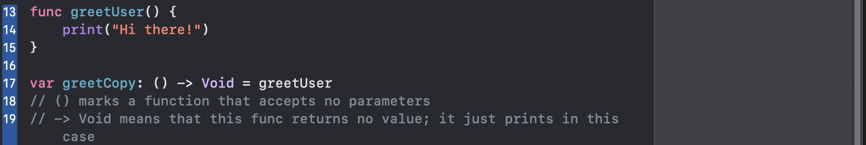

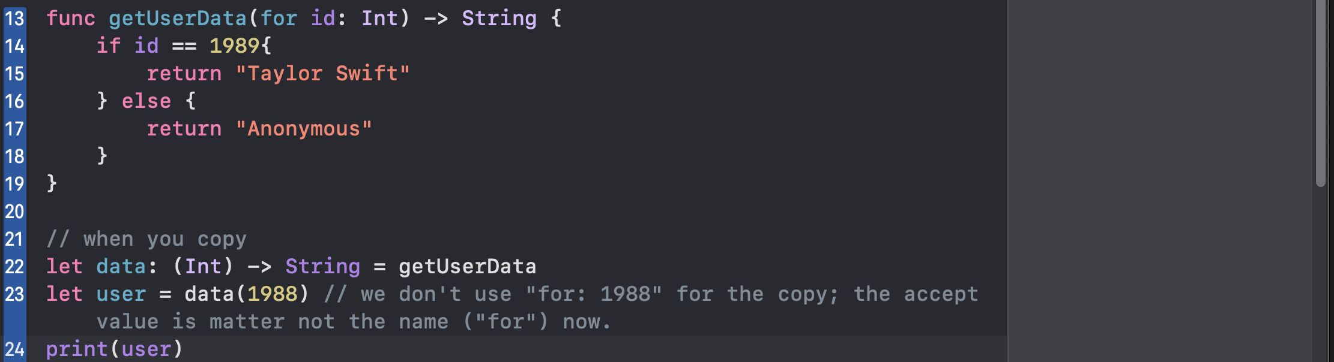

Closure: it is heavily used in swift

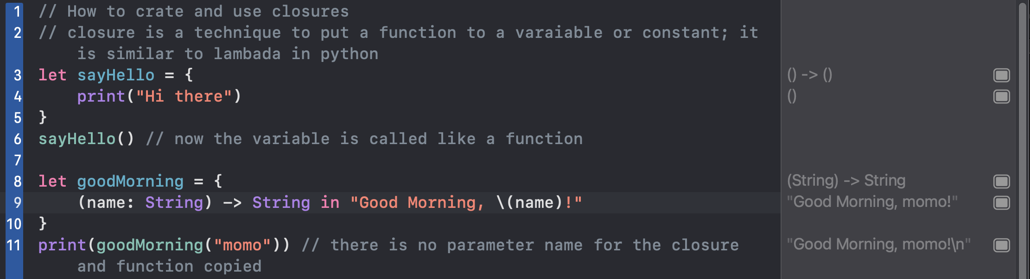

Learn more about sorted(by:…) in https://www.hackingwithswift.com/example-code/arrays/how-to-sort-an-array-using-sort

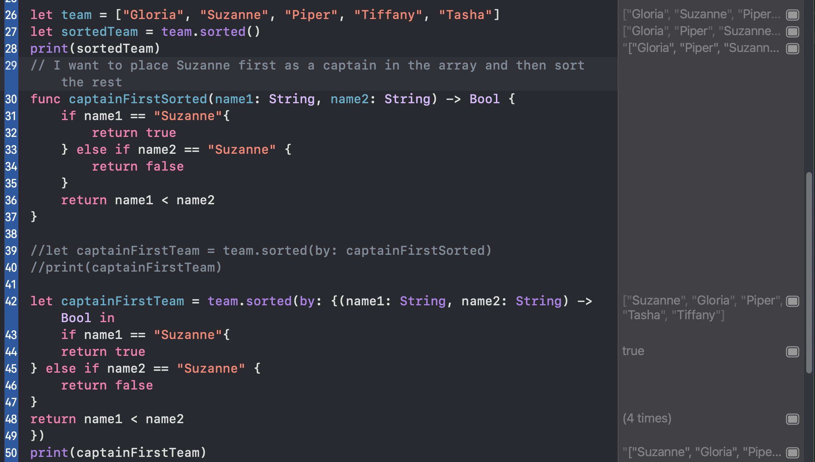

Shorthand 1

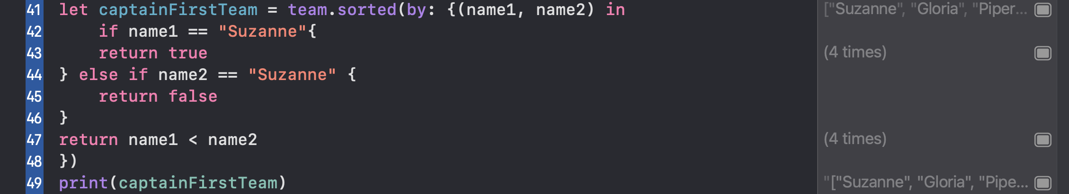

Shorthand 2: using trailing closure; note: the parenthesis for name1 & name2 can be removed

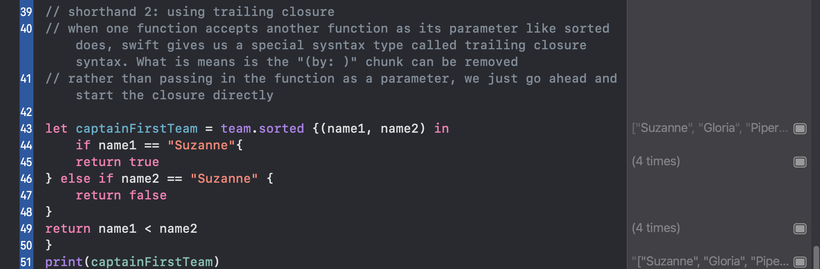

Shorthand Syntax method: this method is not recommended here since $0 or $1 are used more than 1 time

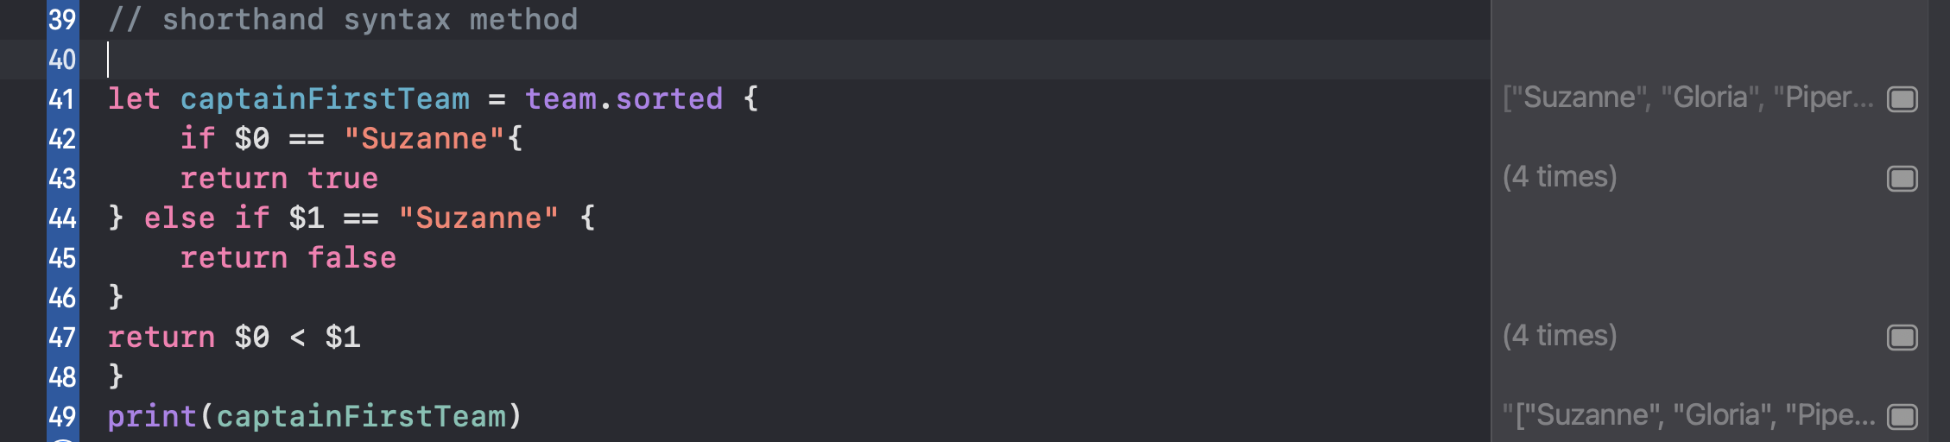

Reversed sort: using shorthand syntax here is recommended: $0 & $1 are used only once





When not to use the closure syntax?

* When the closure’s body is long
* When $0, $1, …, $10 are used multiple times
* When we end up with three or more parameters; ex: $0, $1, $2, …

Find players whose name begins with capital "T"



// use map function to transform every item in an array



// How to accept functions as parameters; note: we can’t use print(generator) inside makeArray because it causes an error. But we can use the return value from generator to perform sth else

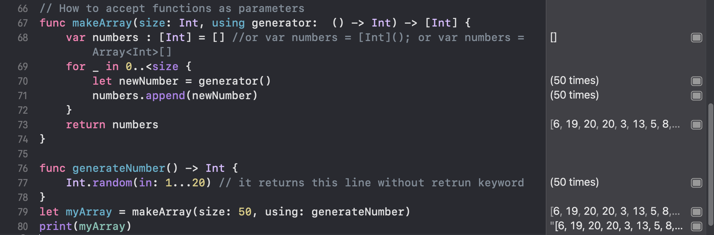

//or we can use closure here



//or

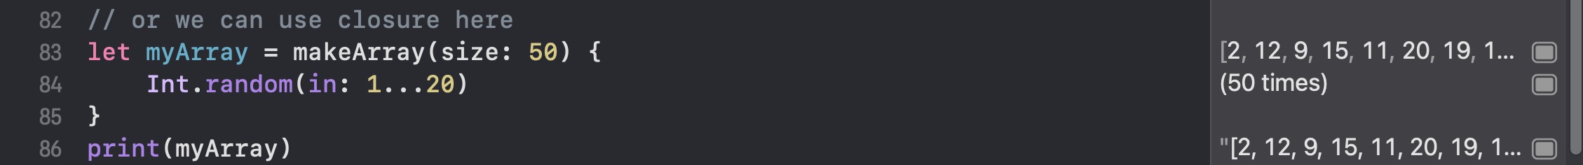

Example 2:

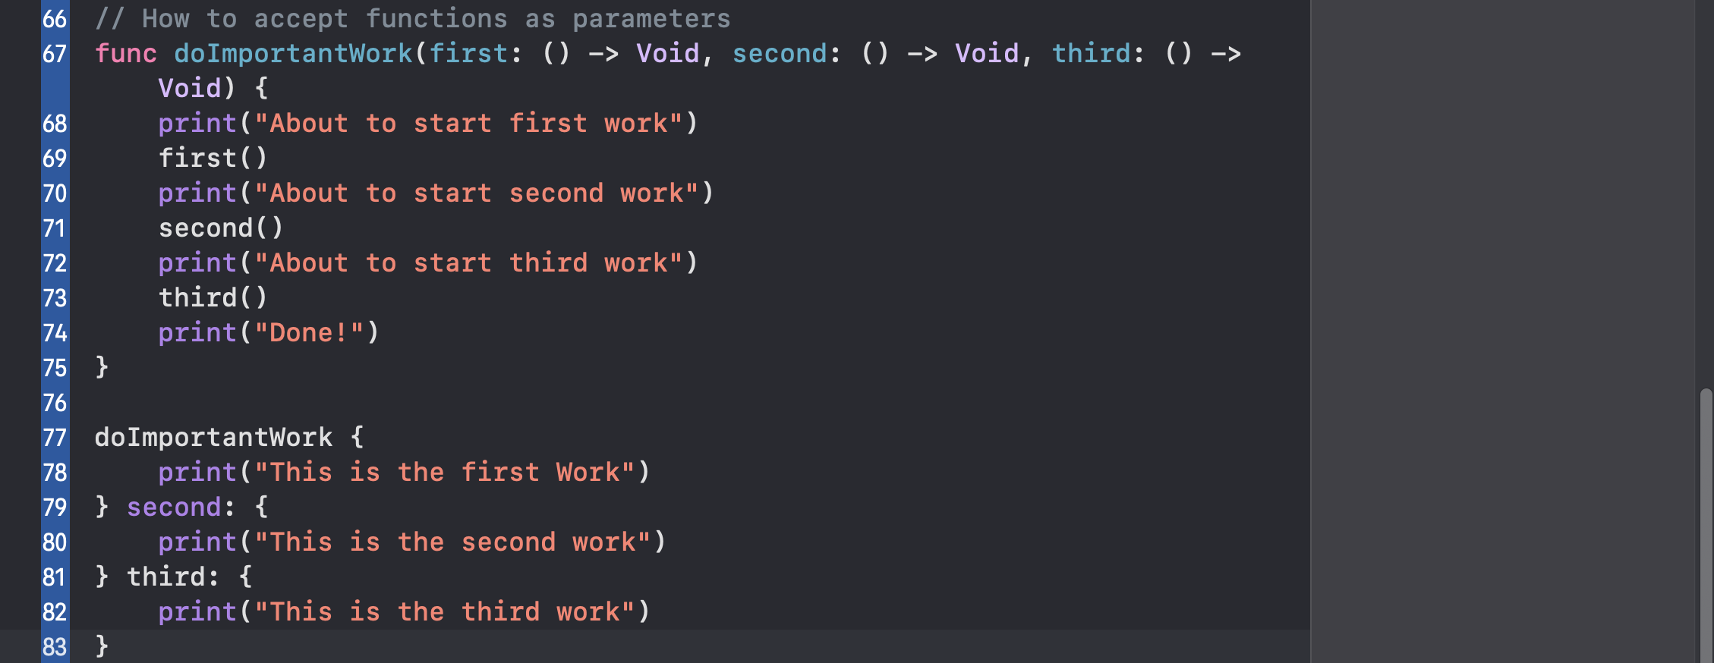

Closure summary

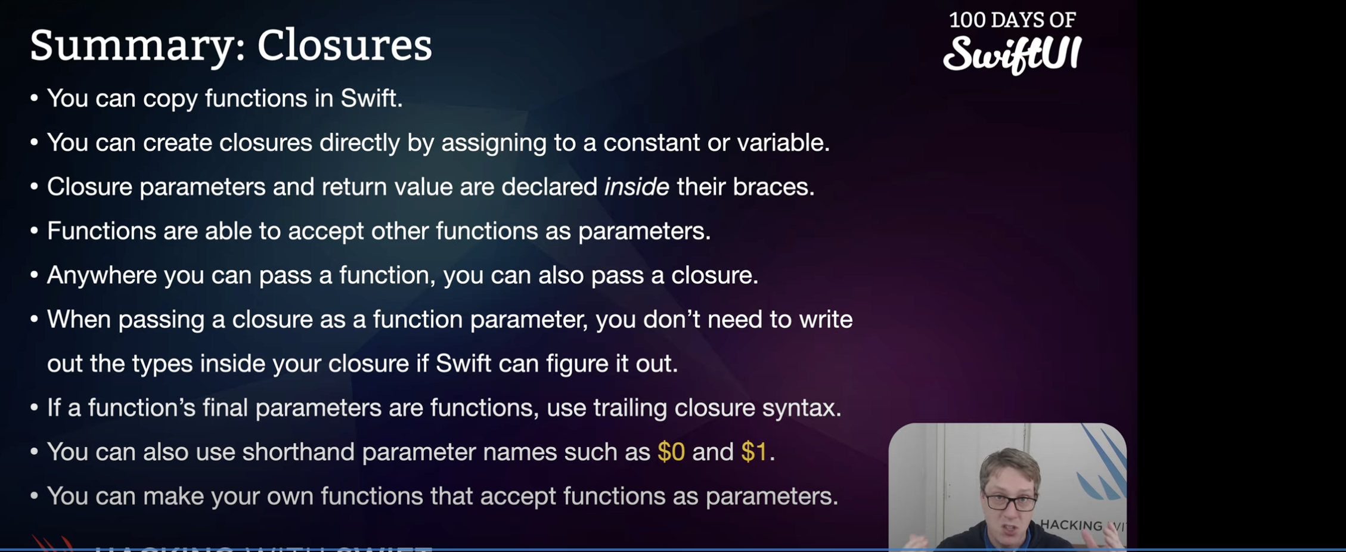

// how to create your own structs:

Swift Structs let us create our own custom complex datatypes; complete with our own variables and functions.

// structs have 2 kinds of properties: the first is stored property where you place a value into the struct directly. The second is called a computed property, and it recalculates the value of the property every time it’s accessed

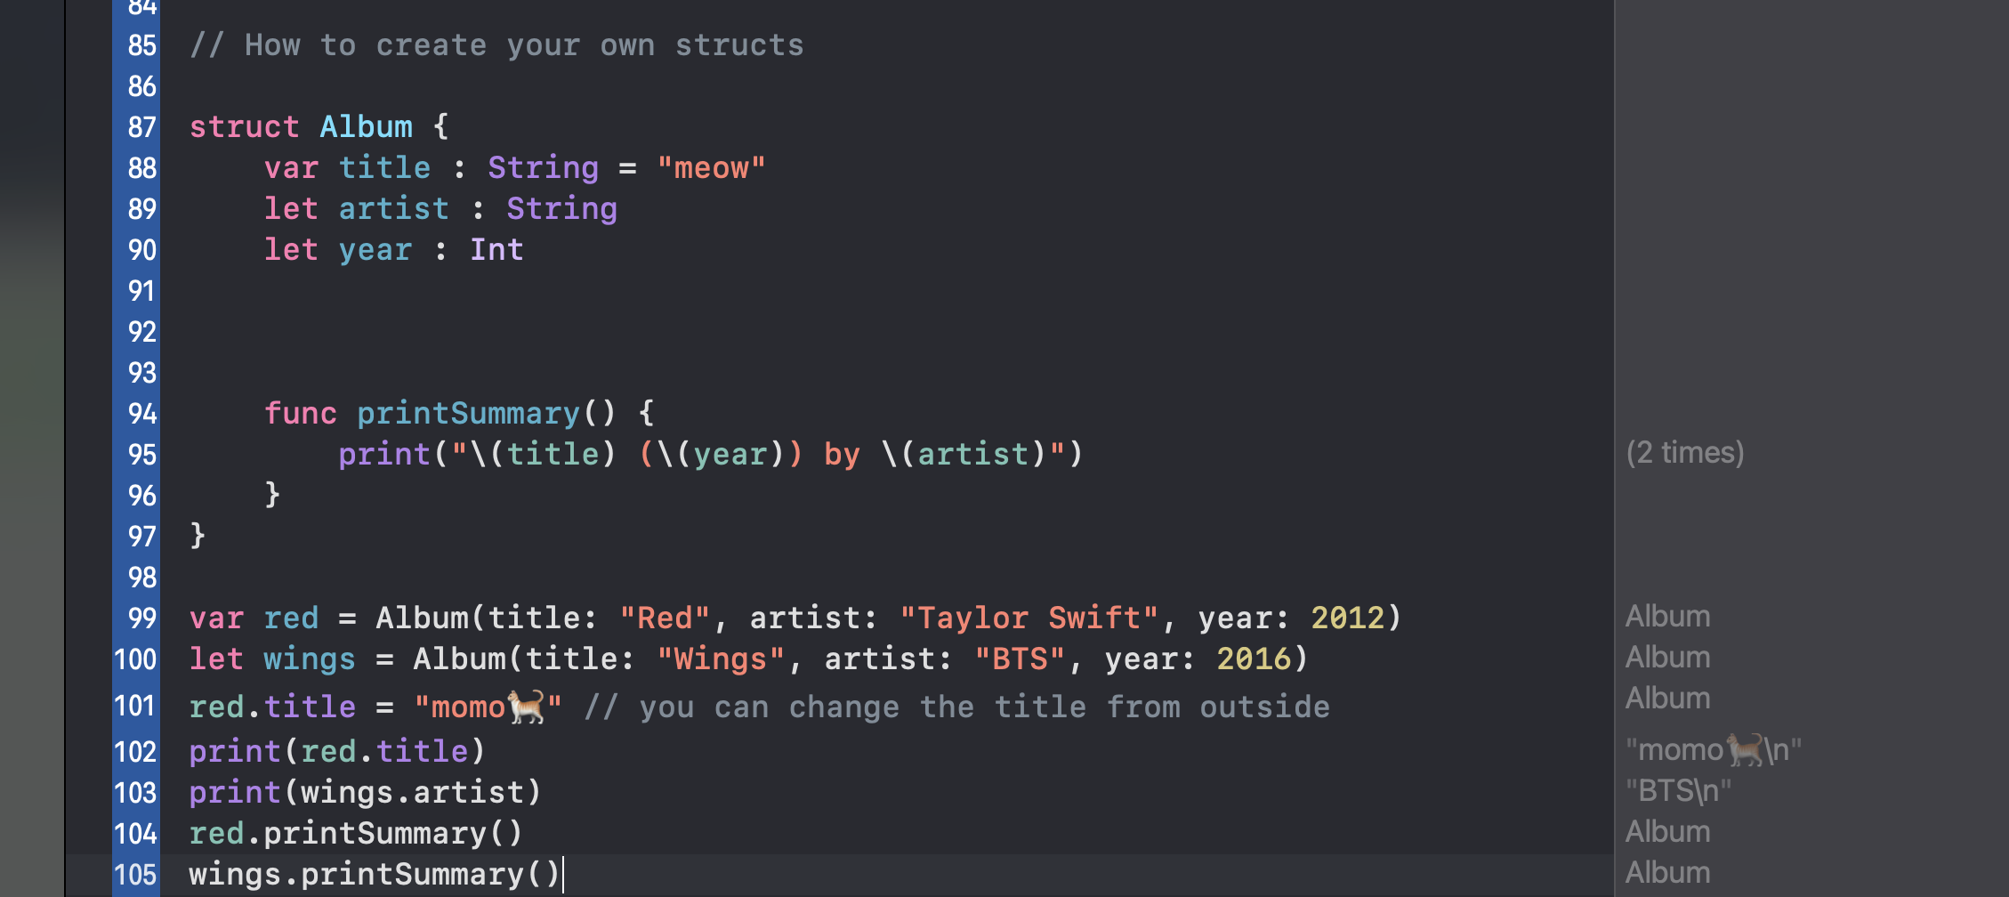

Example 2:

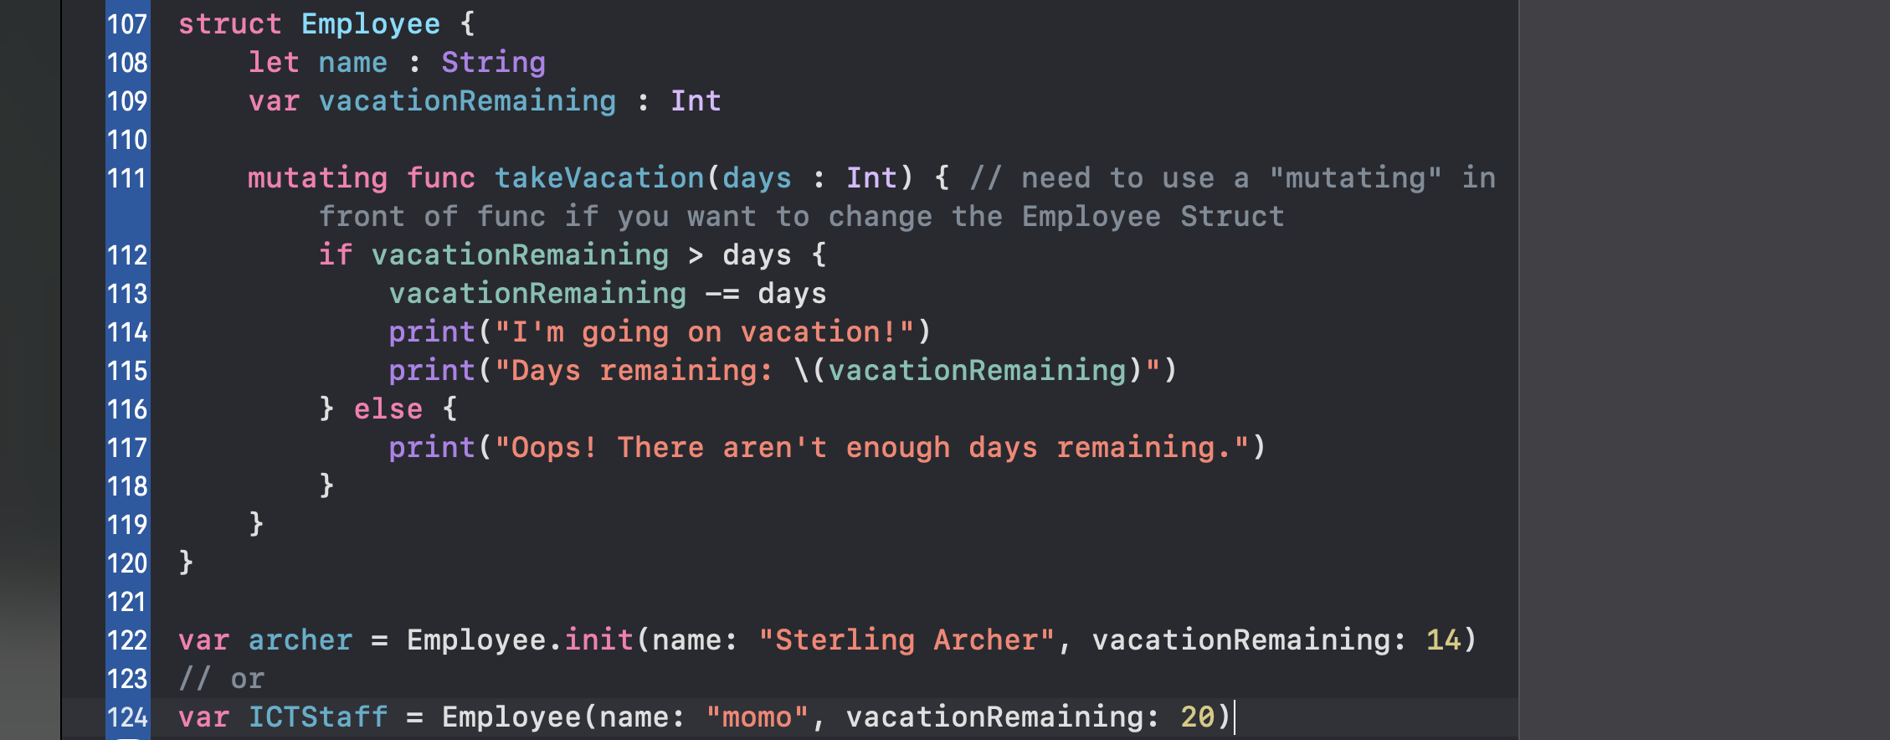

//getter and setter: code that reads (getter); code that writes (setter)

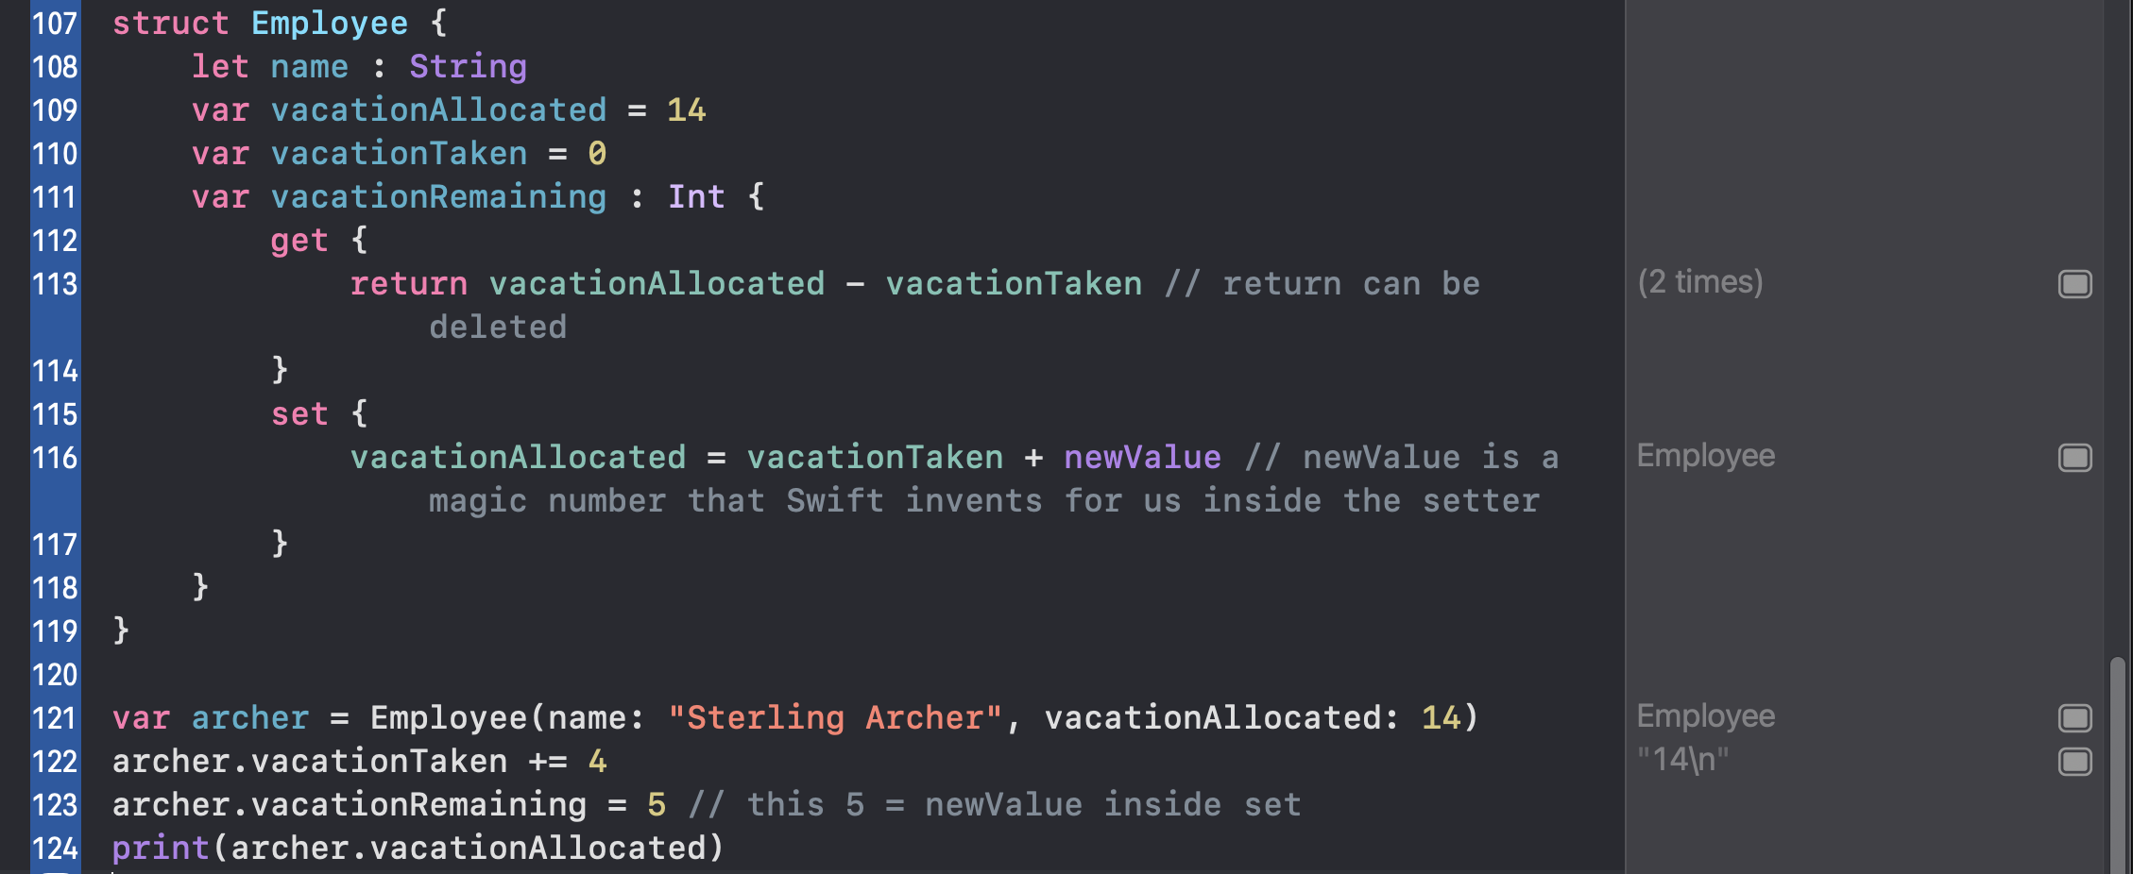

Read more about getter and setter

<https://www.advancedswift.com/getters-setters-swift/>

// Swift lets us create property observers which are special pieces of code that run whenever a properties value changes; these come in two forms, it’s a “did set” observer that runs code after the properties changed, and “will set” when it’s about to change.

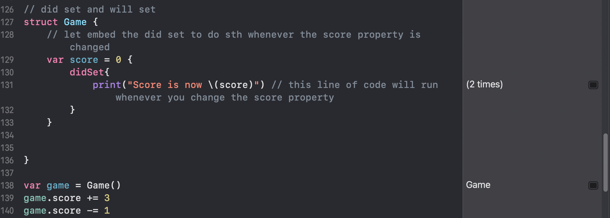

Example 2

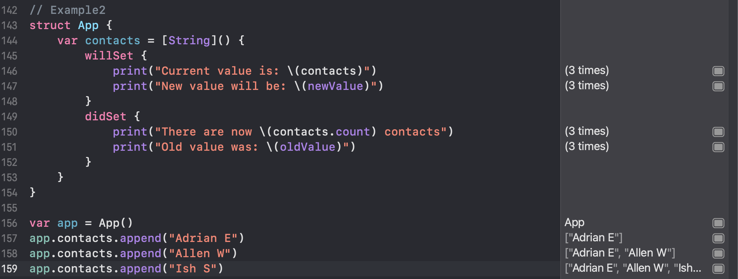

Result

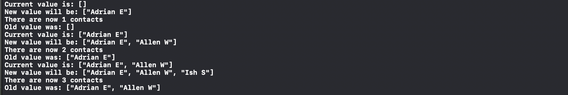

// How to create custom initializers

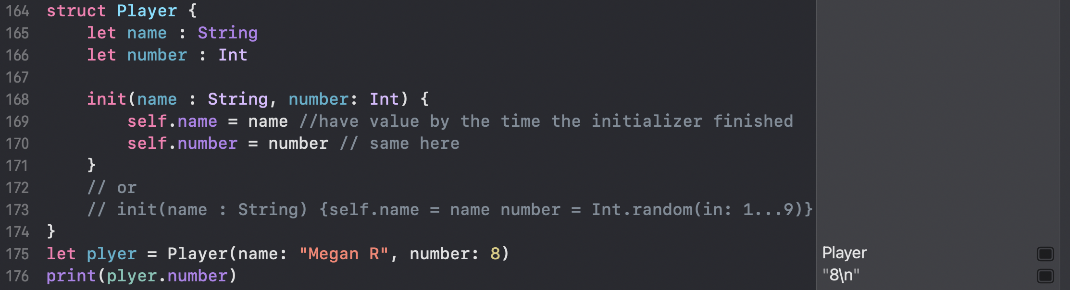

// How to limit access to internal data using access control

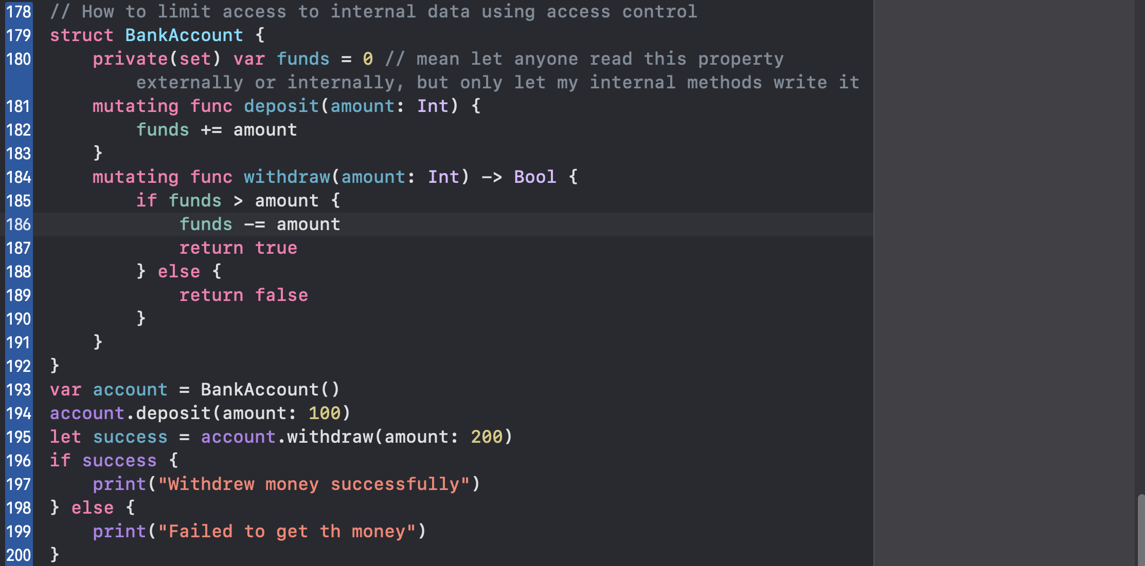

private Don’t let anything outside the struct use this.

Fileprivate Don’t let anything outside the current file use this

public Let anyone, anywhere use this

private(set) Let anyone read this property externally or internally, but only let my internal methods write it

// static properties and methods

// sometimes, we want to add a property or method to the struct itself, not the instance. We do this for 2 reasons: first, we use it for example data; second, to store constant data that has to be accessed in various places in my program. we use static to achieve this goal

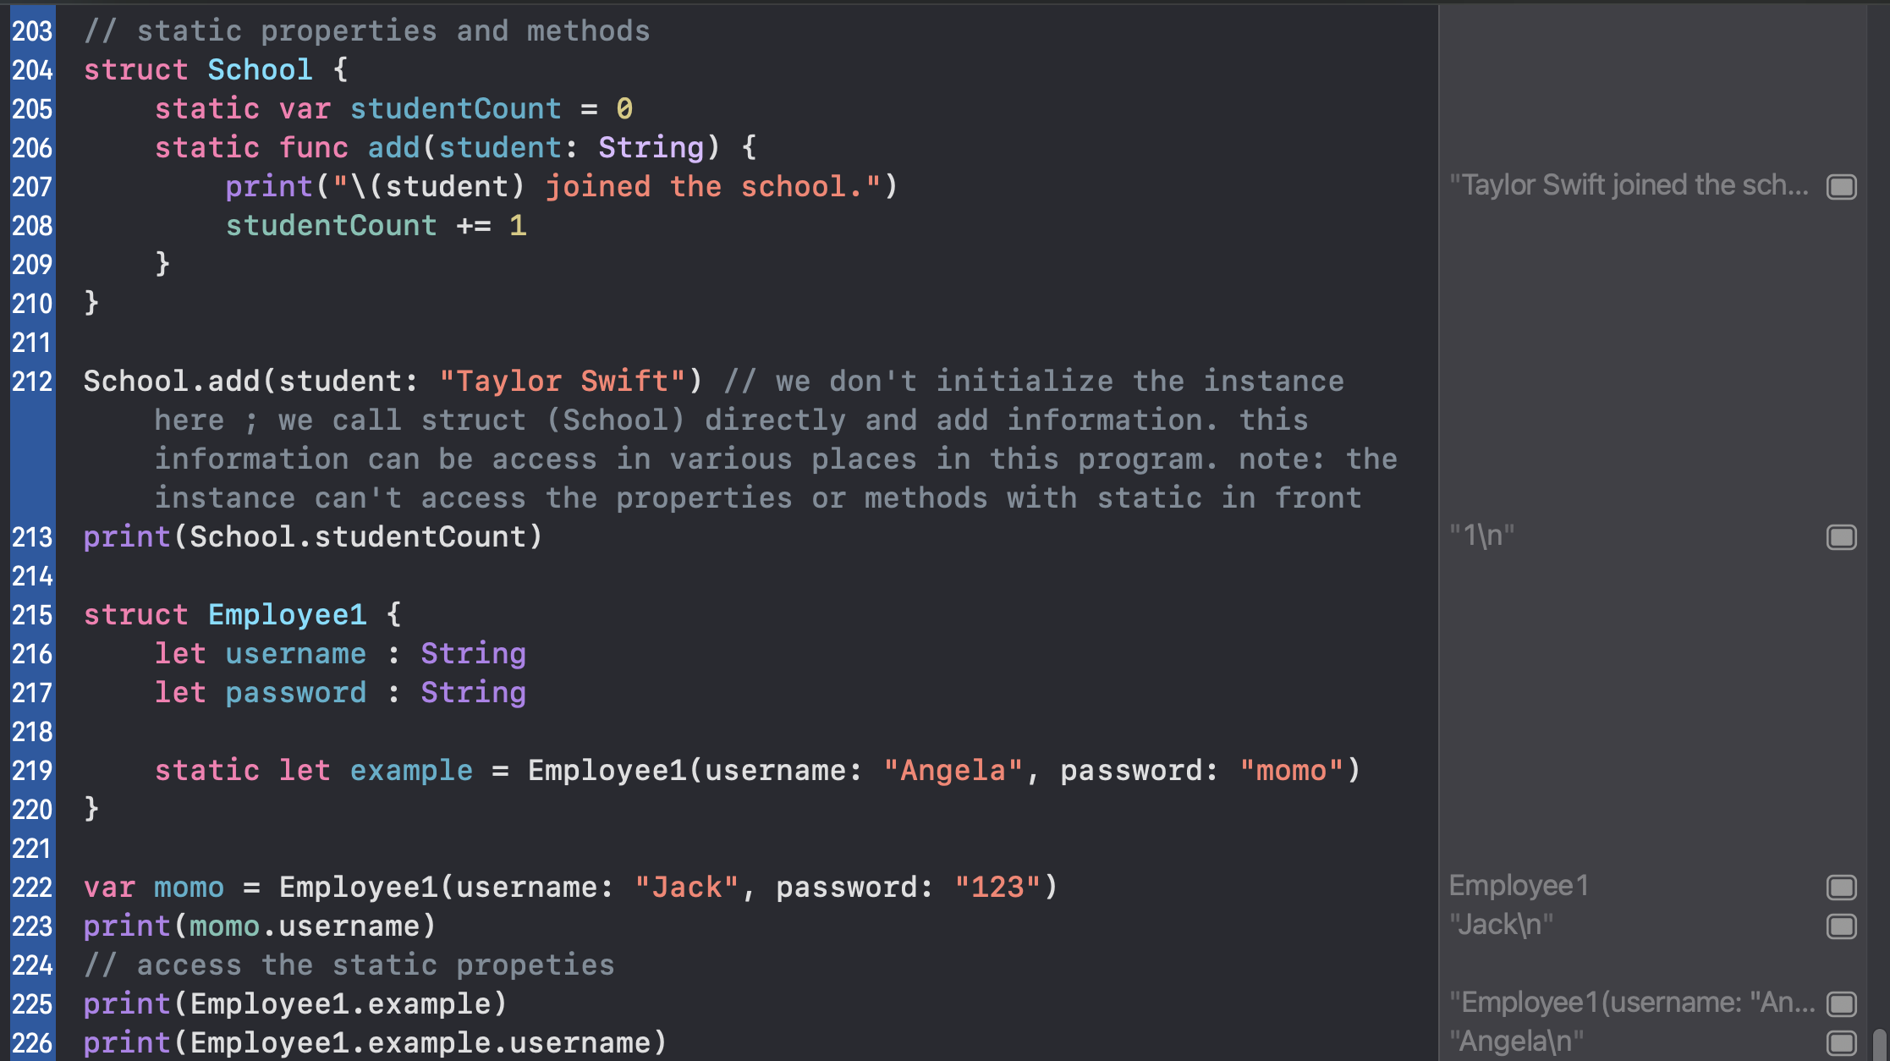

// if you want to mix and match static and non-static properties and methods, there are two rules. First, if you want to access non-static stuff (regular properties and methods) from static stuff (static properties and methods), you can’t. Second, if you are in a non-static properties or methods, you can read the static version.

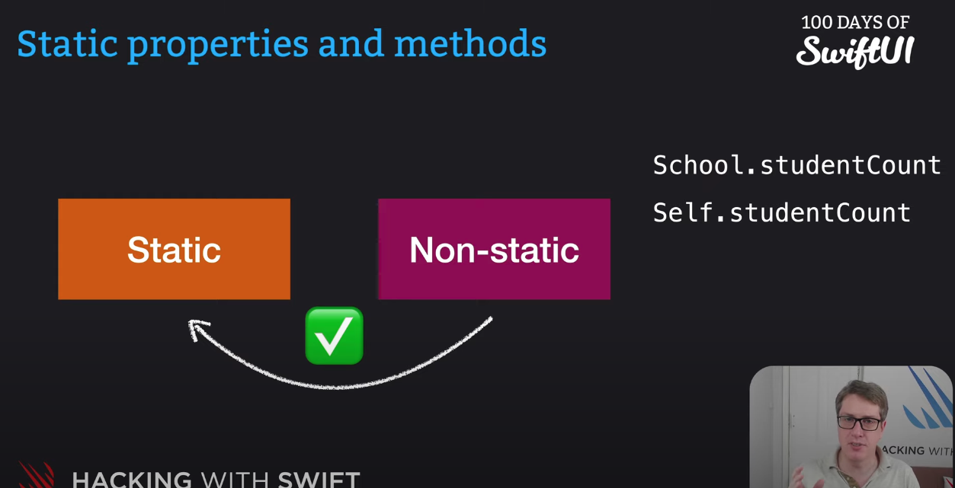

// self (lowercase) vs self (capital S)

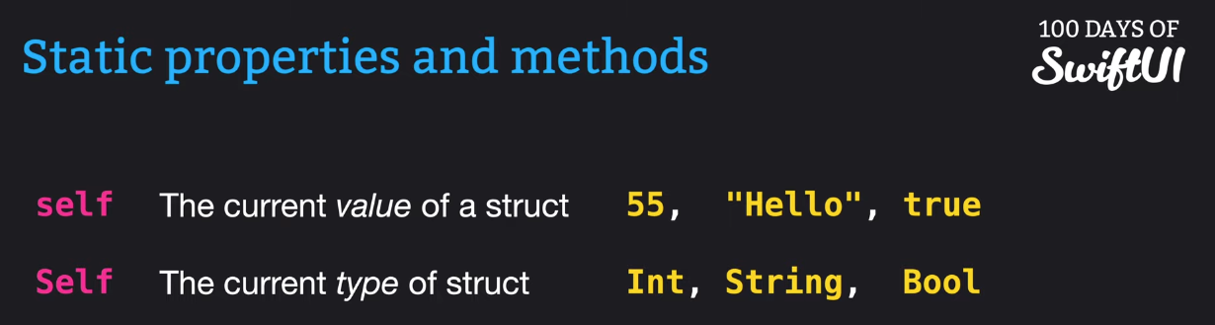

// Summary: Structs

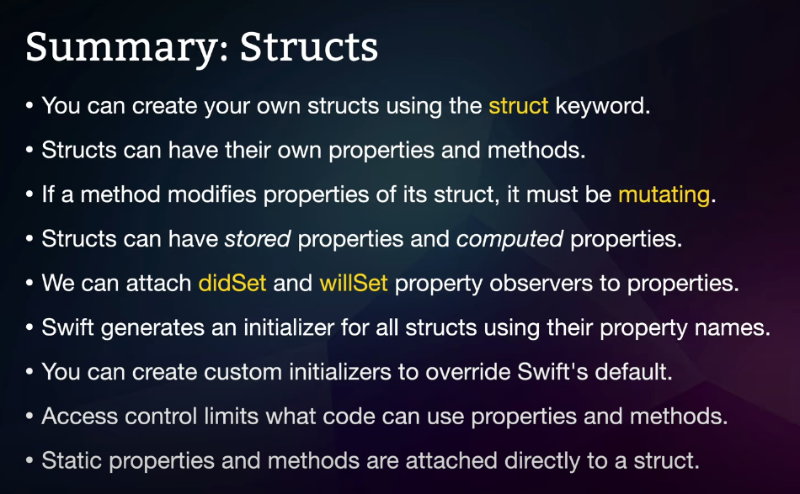

// structs vs classes

+ Similarity

* You get to create and name them
* Add properties, methods, property observers, and access control
* Create custom initializers to configure new instances

+ 5 differences of class

* You can make one class build upon functionality in another class
* Swift won’t generate a member-wise initializer for classes
* If you copy an instance of a class, both copies share the same data
* We can add a reinitializer to run when the final copy is destroyed
* Constant class instances can have their variable properties changed

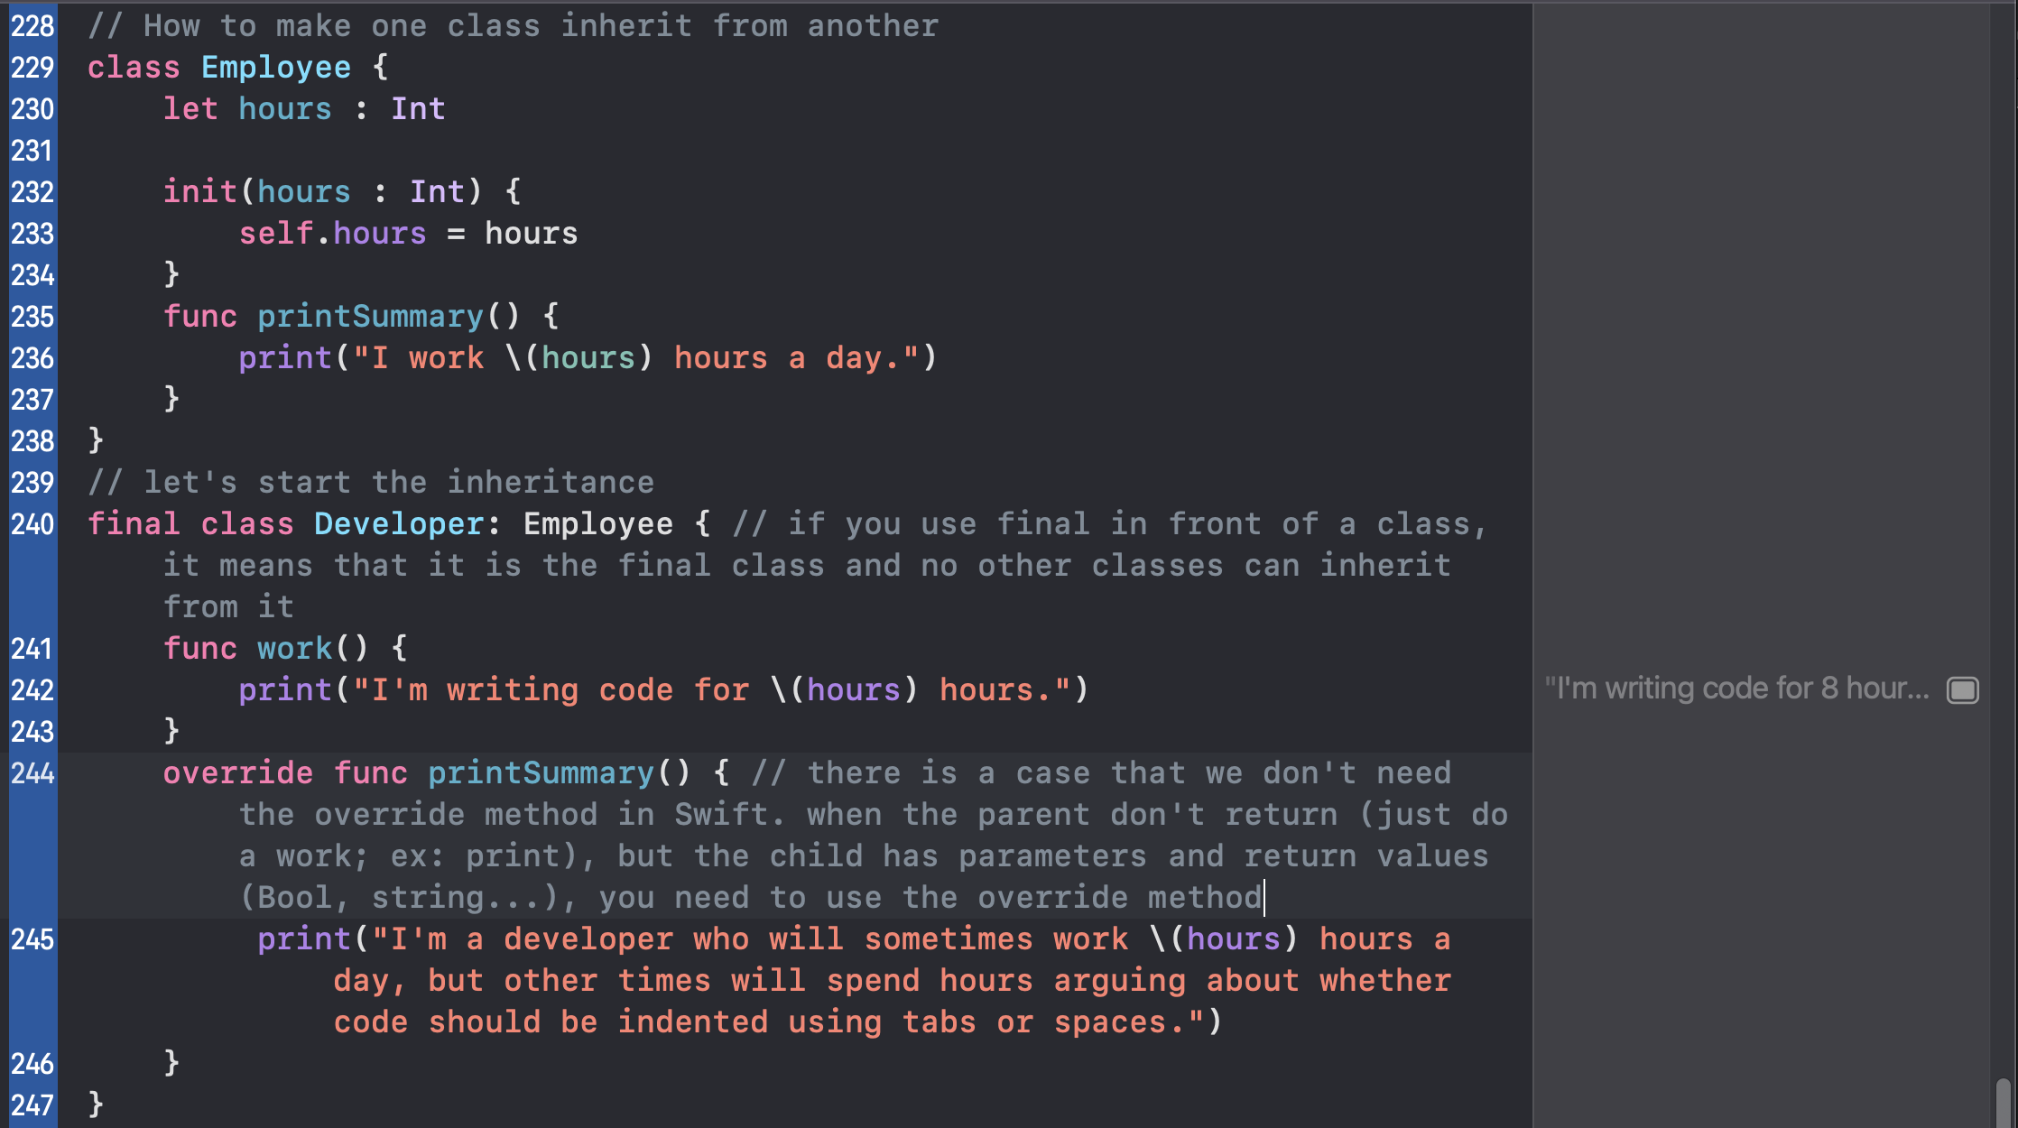

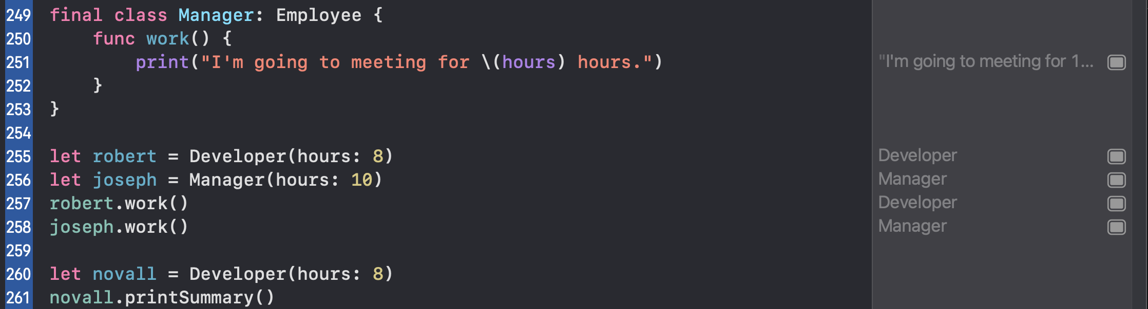

// initializer in child class

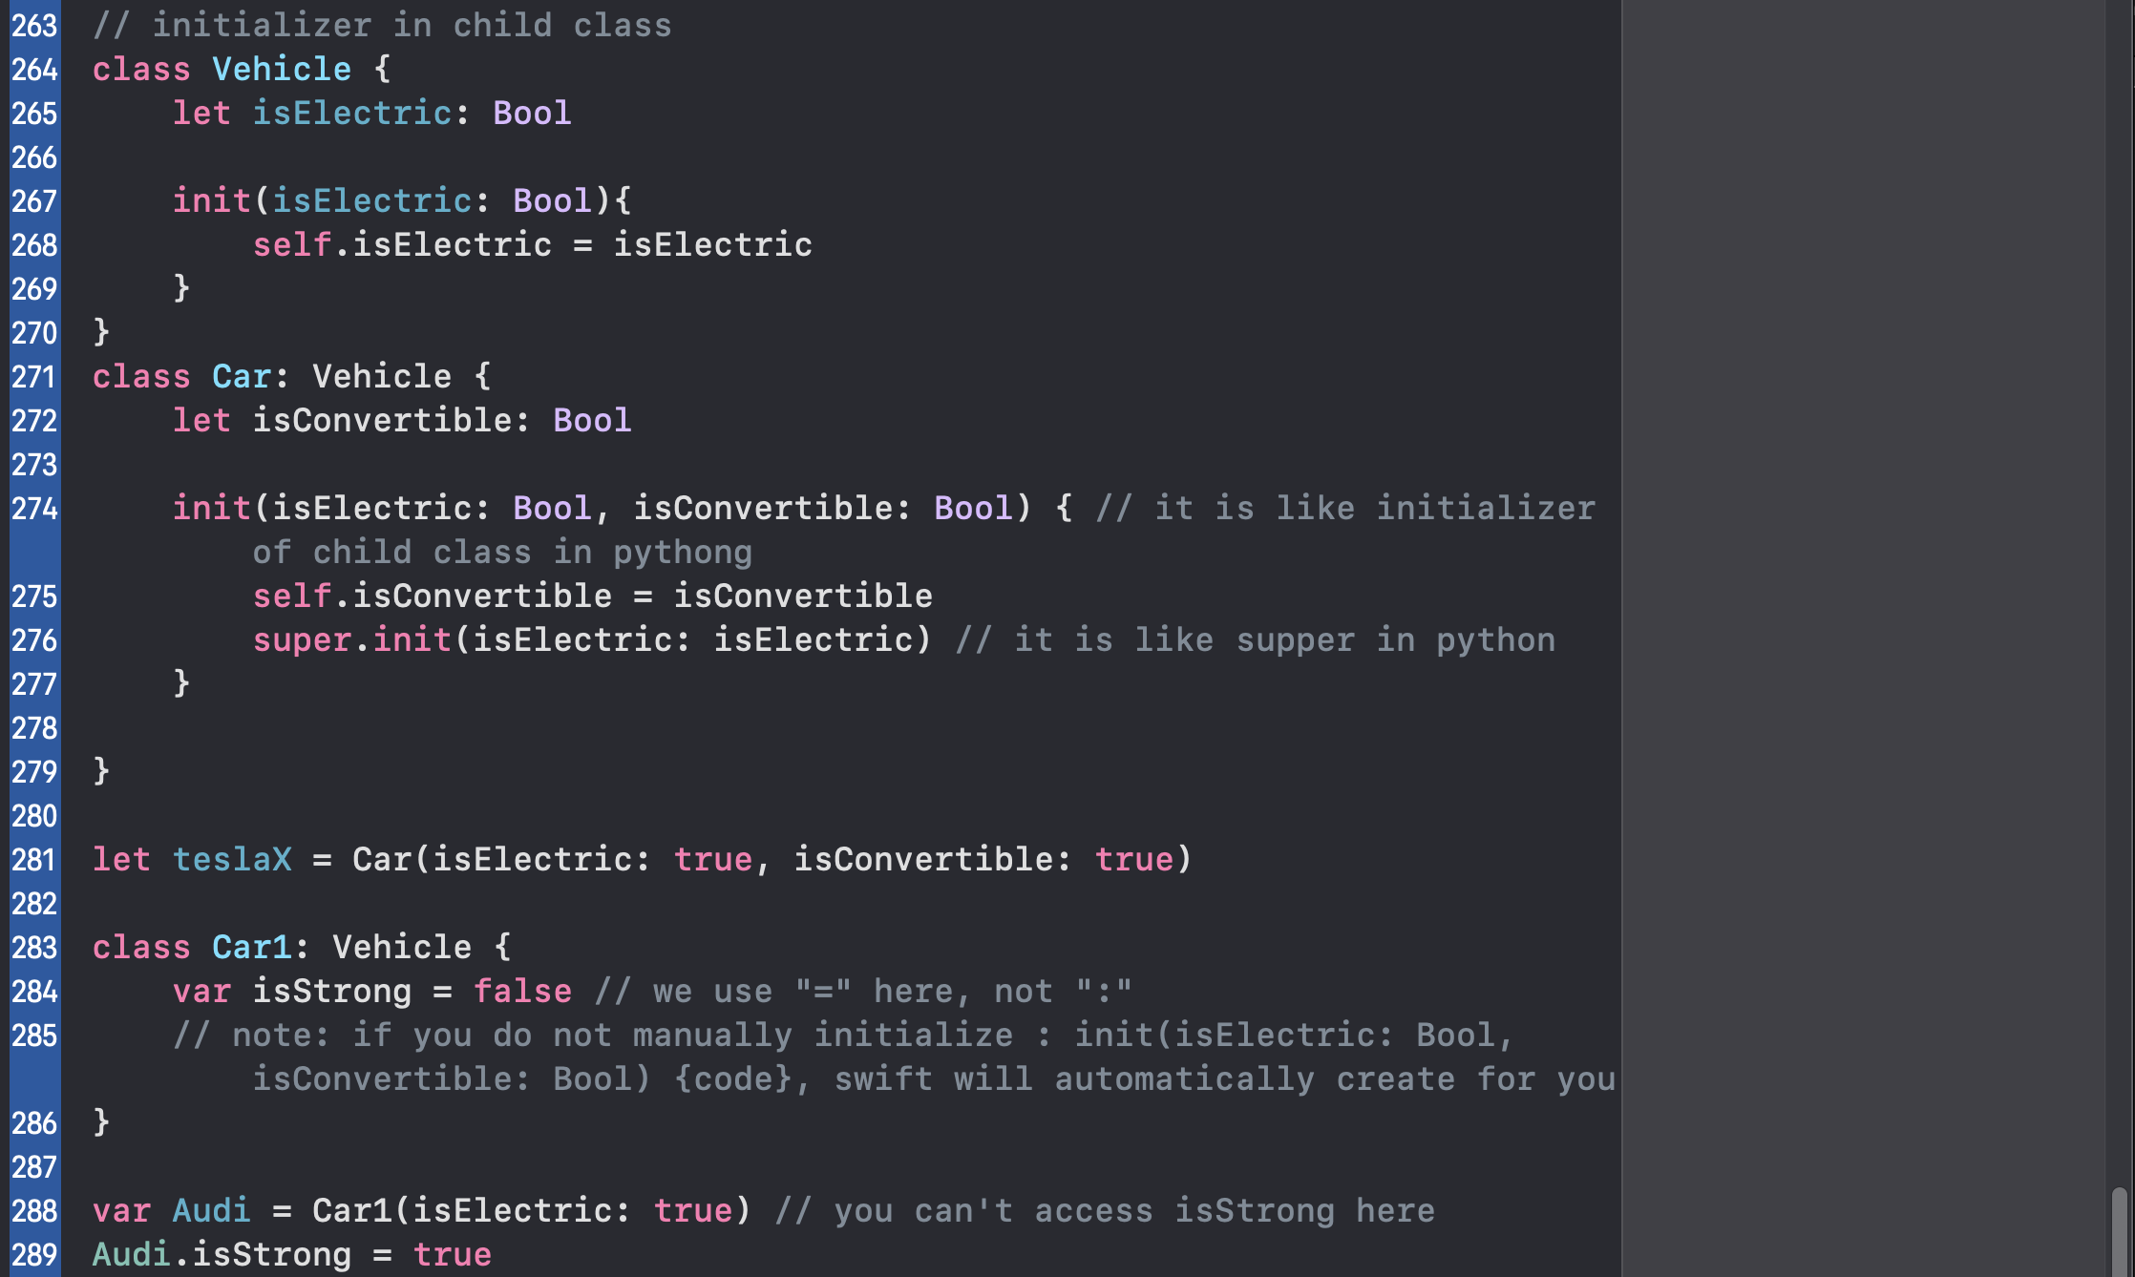

// Shallow copy

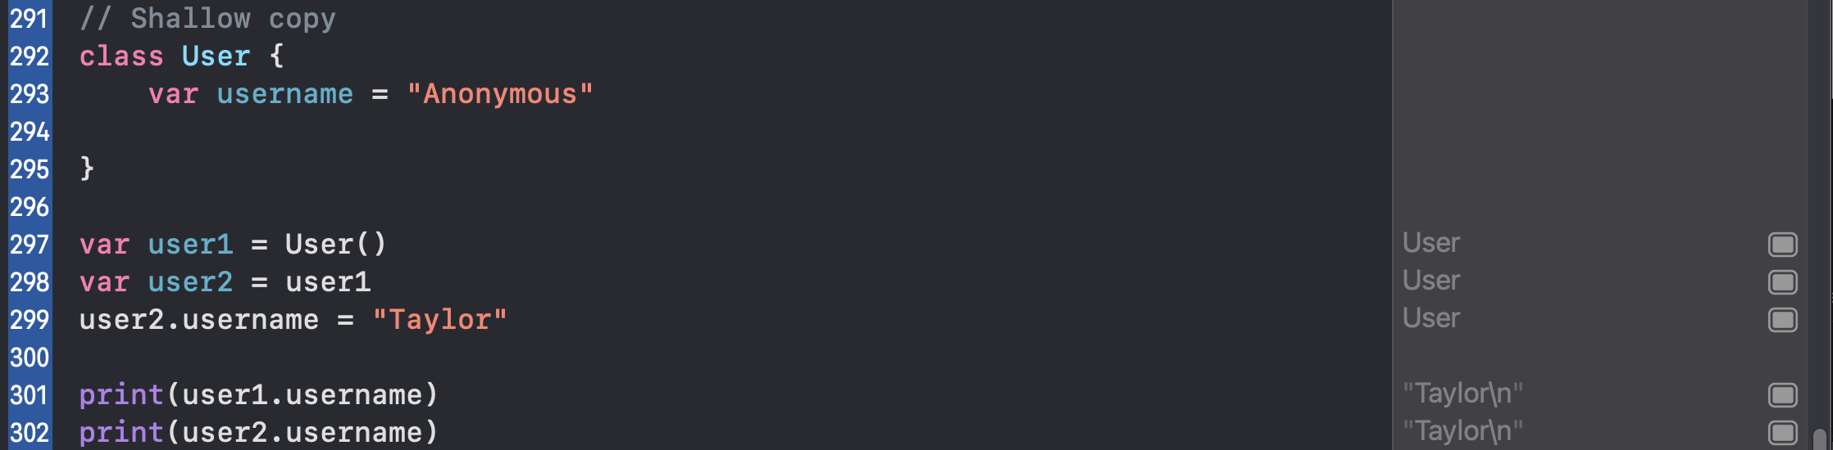

// Deep copy

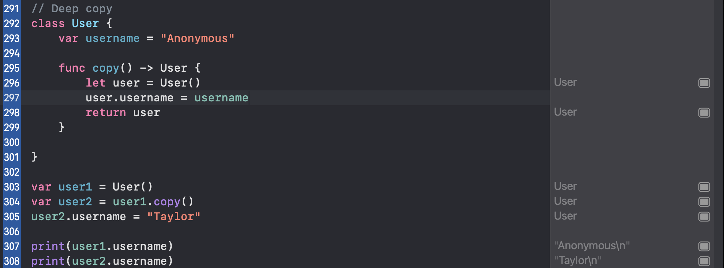

// How to create a deinitializer for a class

1. You don’t use func with deinitializers
2. Deinitializers can never take parameters or return data
3. Deinitializers run when the last copy of a class instance is destroyed.
4. We never call deinitializers directory
5. Structs don’t have deinitializers

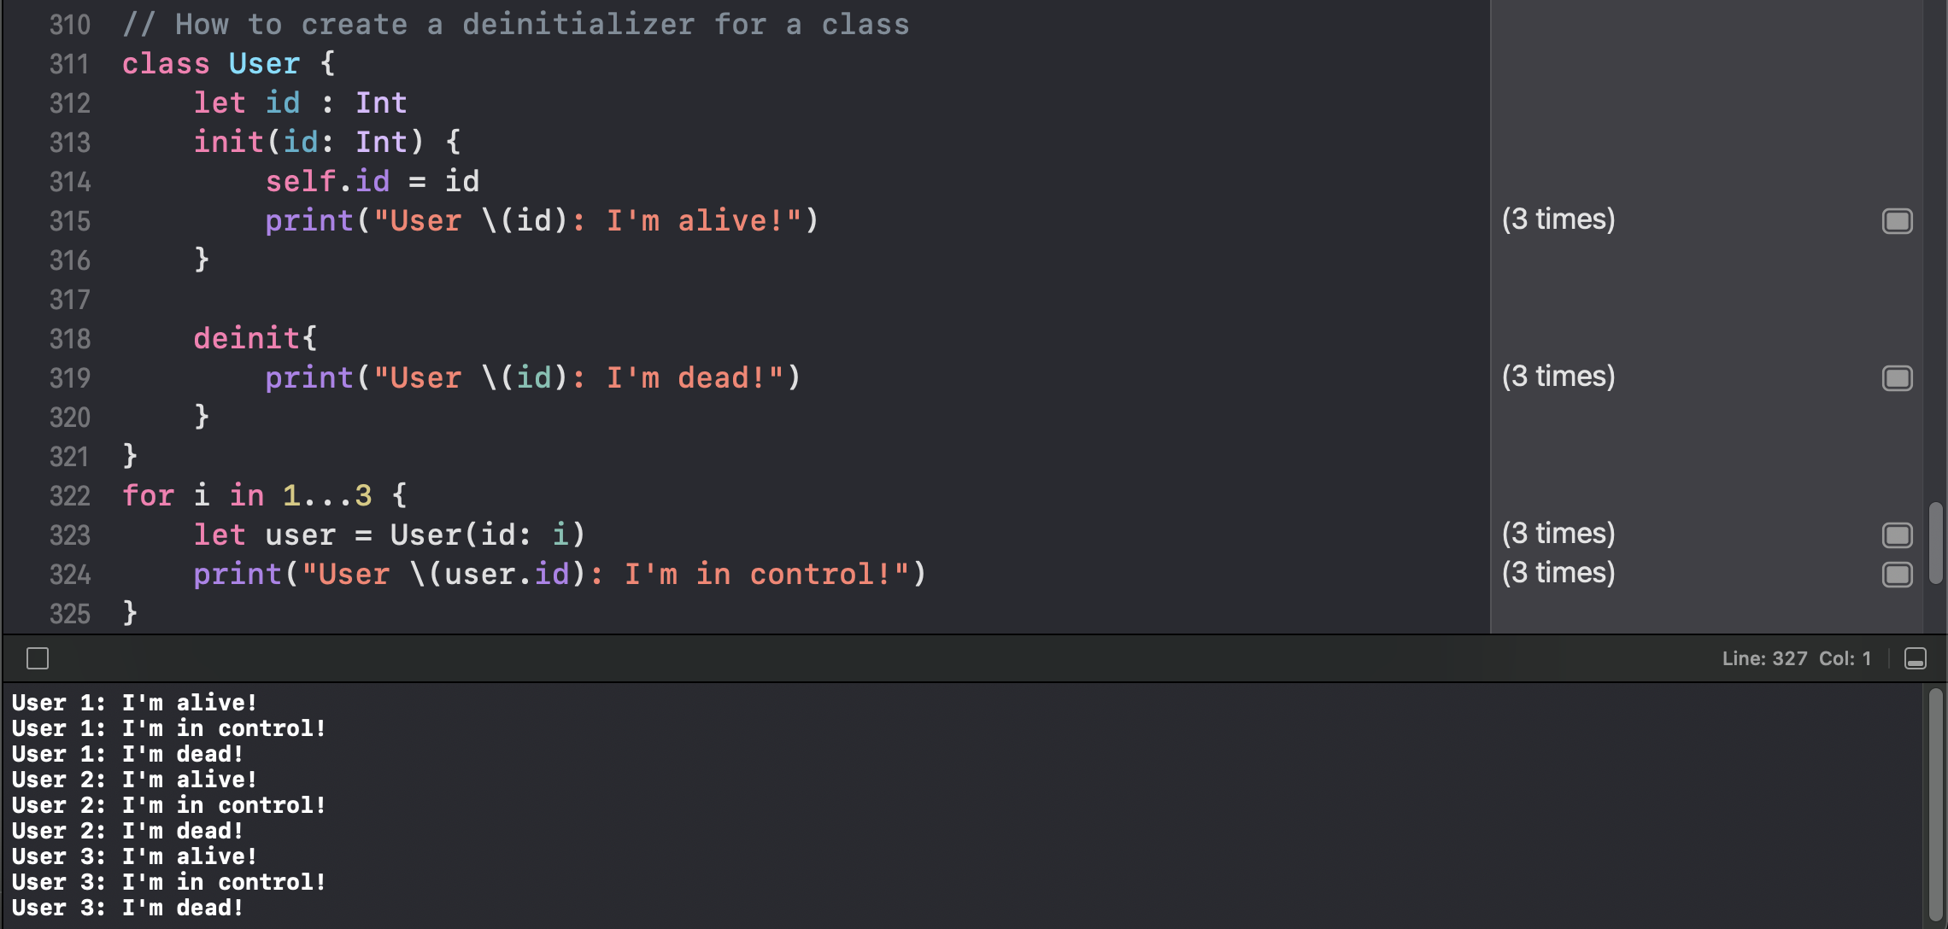

// the deinitializer executes each iteration

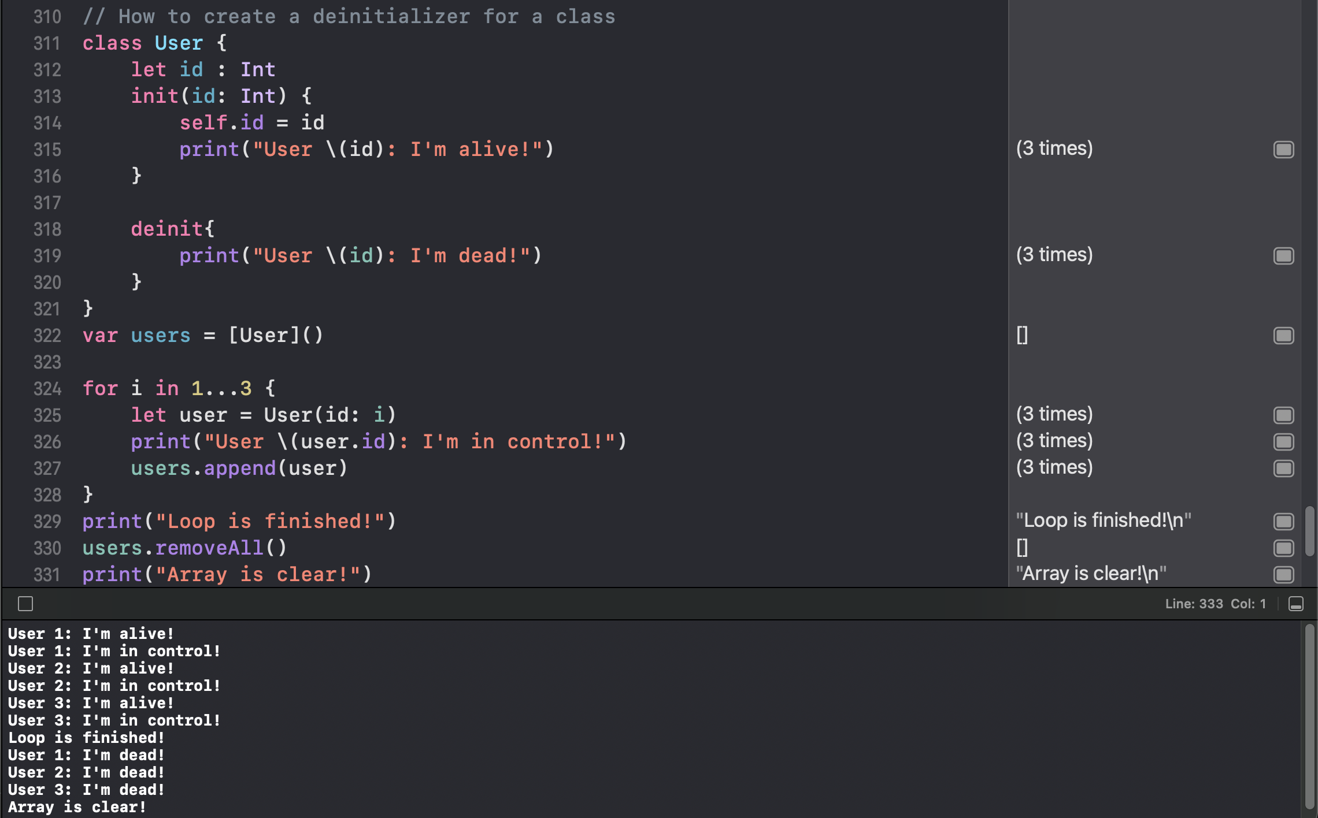

// the deinitializer executes when the array is clear

// Summary: Classes

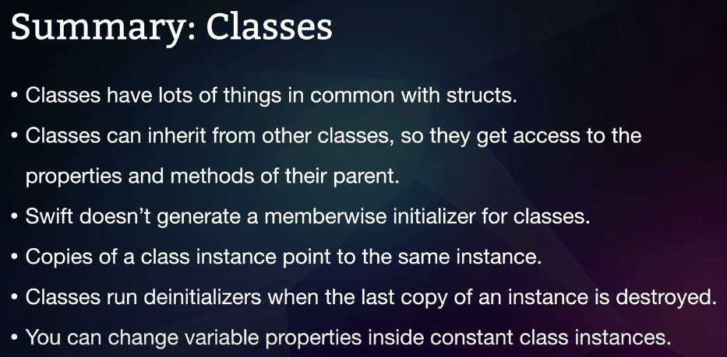

// How to create and use protocols

Protocols are a bit like contracts for our Swift code; they let us define what kind of functionality we expect our types of support and Swift will ensure those types add the required functionality that they follow the rules.

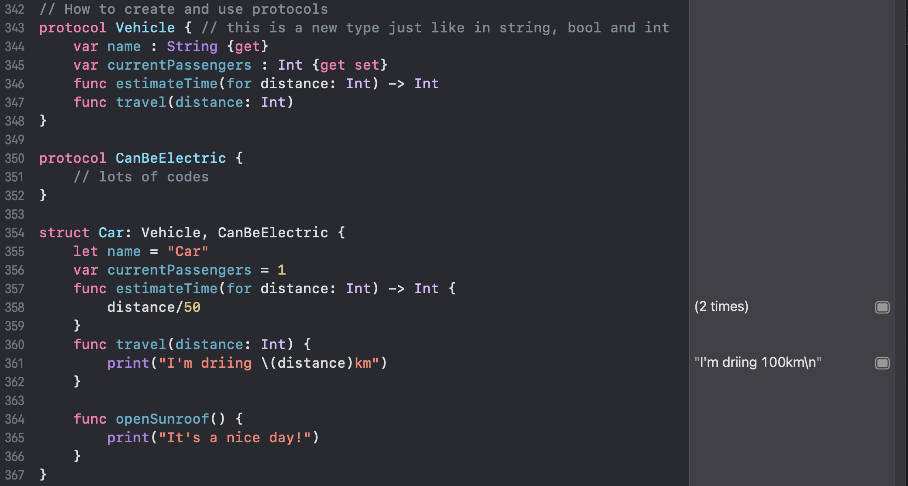

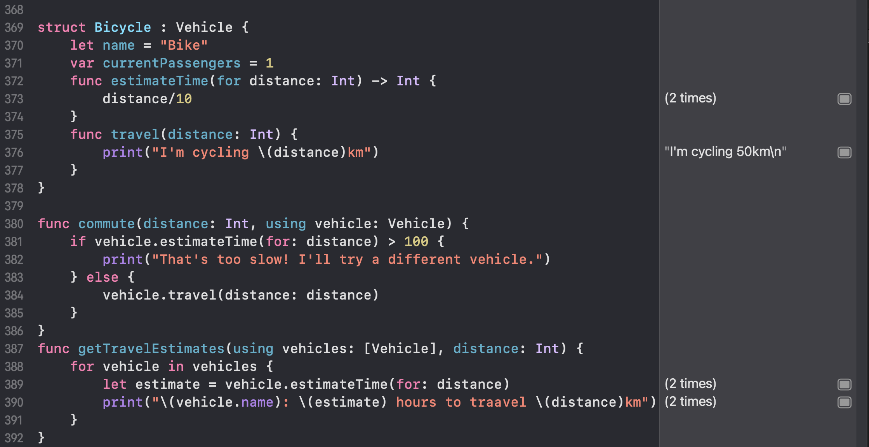

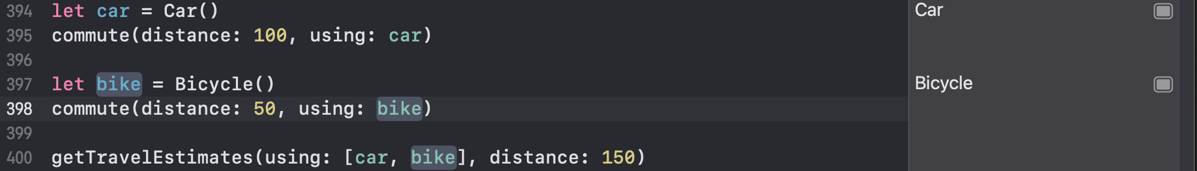

// How to use opaque return types

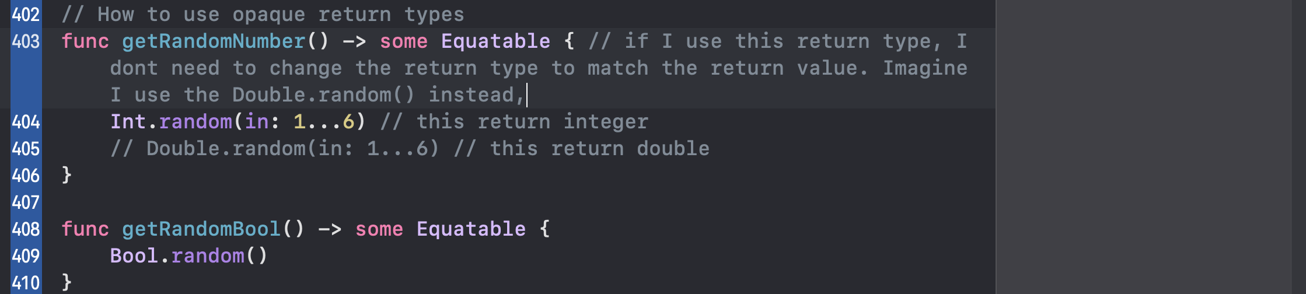

// How to create and use extensions

Extensions let us add functionality to any type including ones we made and apple’s own types too.

// How to create and use protocol extensions

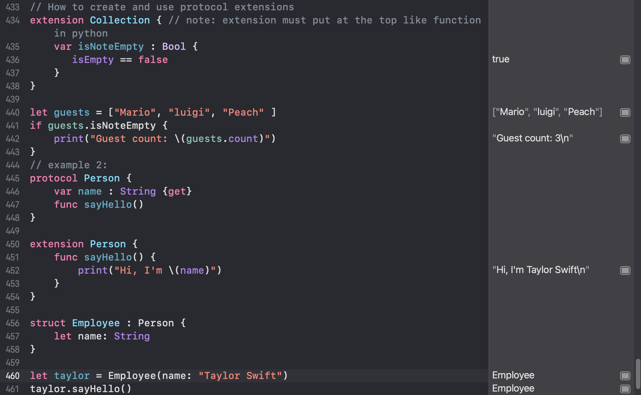

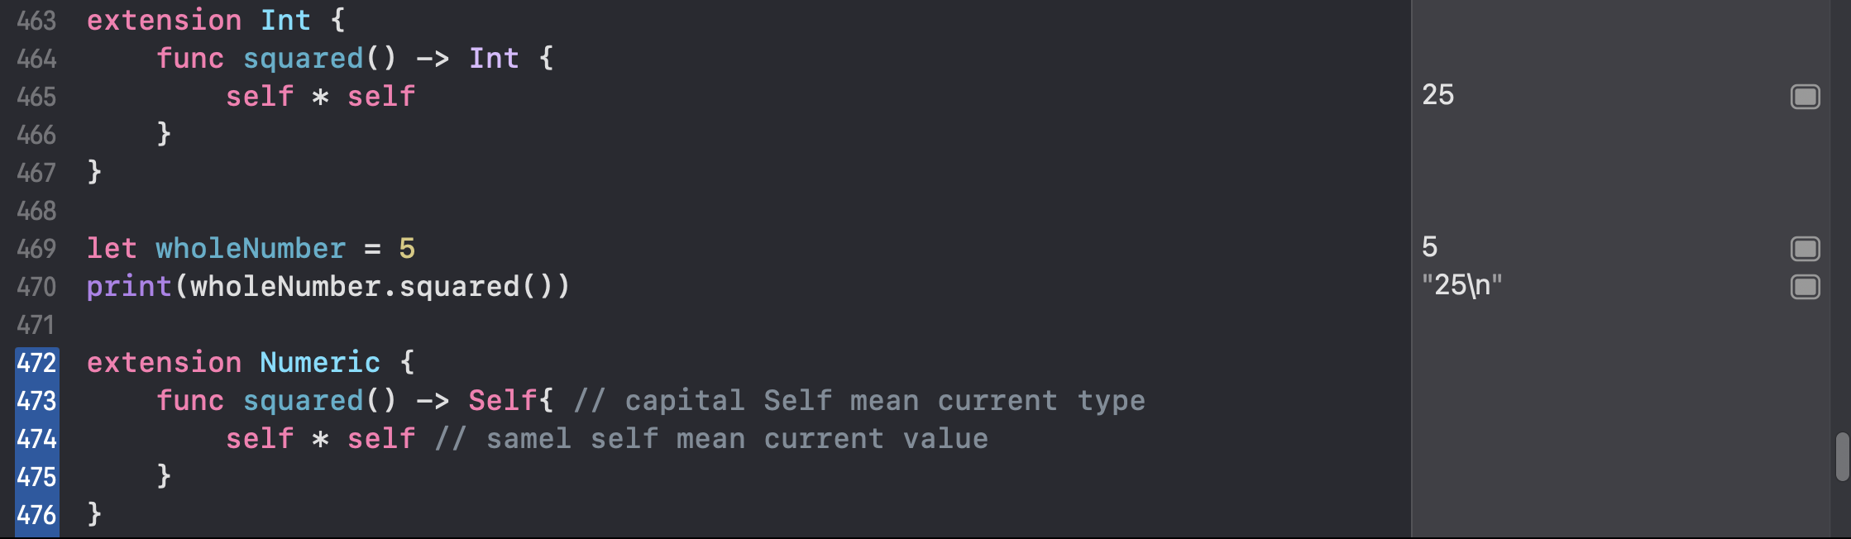

// Summary: Protocols and extensions

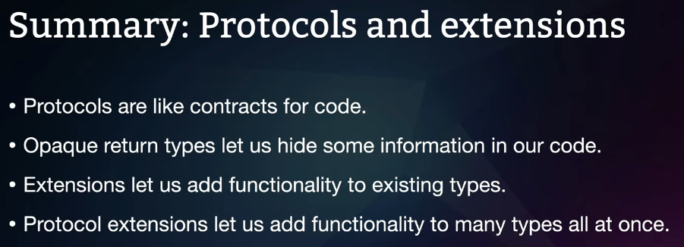

// How to handle missing data with optionals

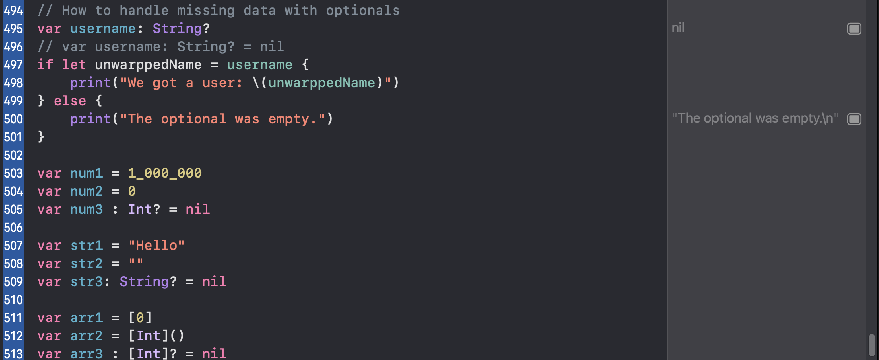

// How to unwrap optionals with guard

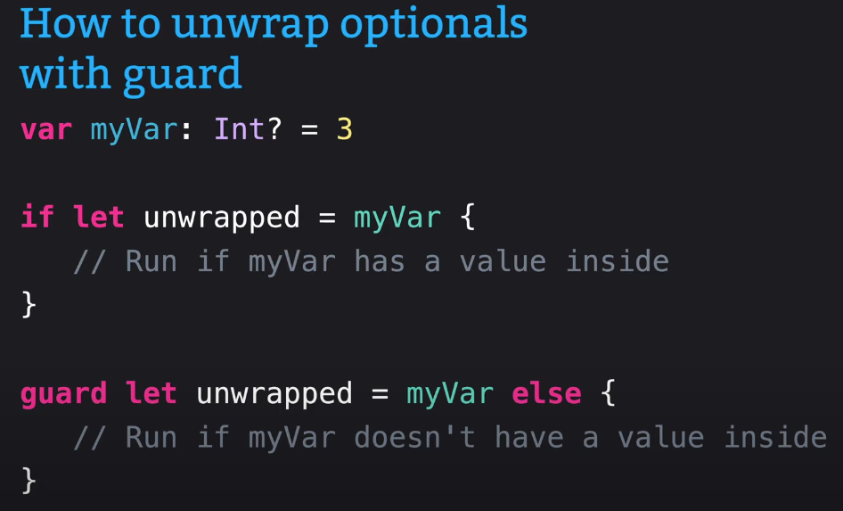

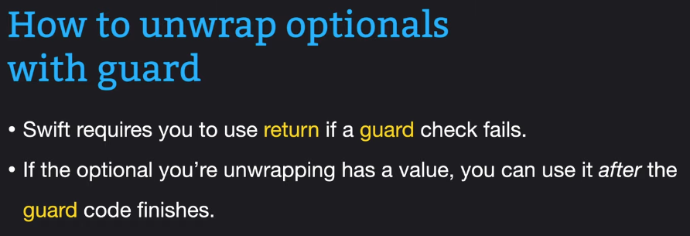

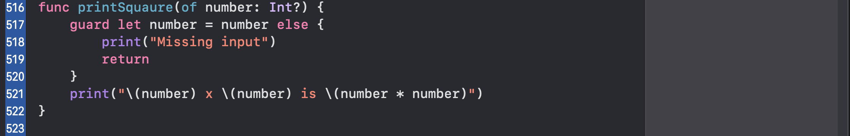

// How to unwrap optionals with nil coalesing

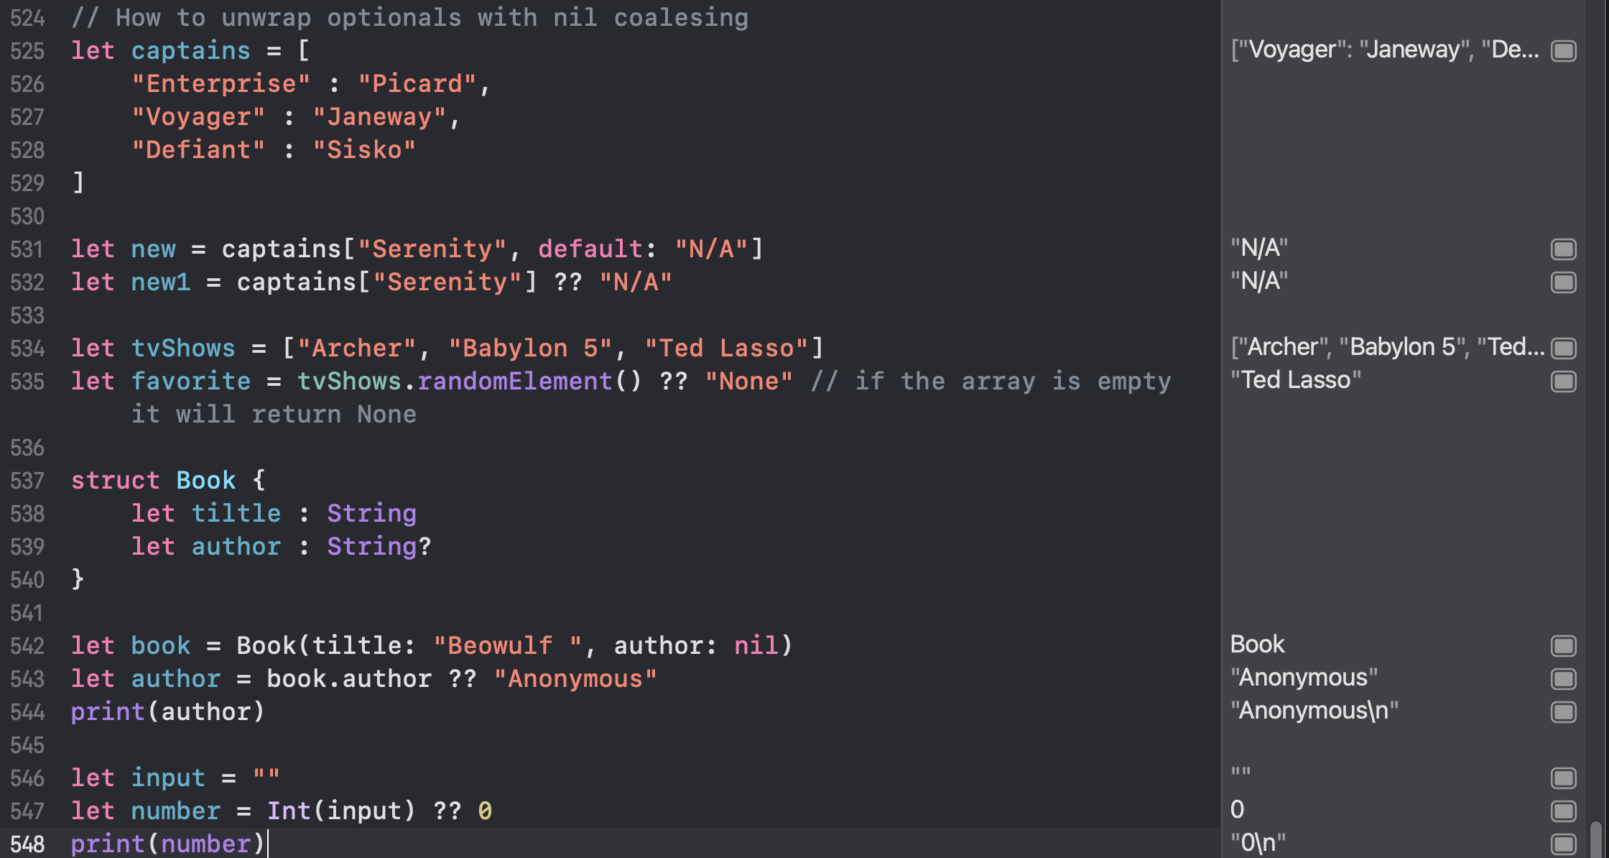

// How to handle multiple optionals using optional chaining

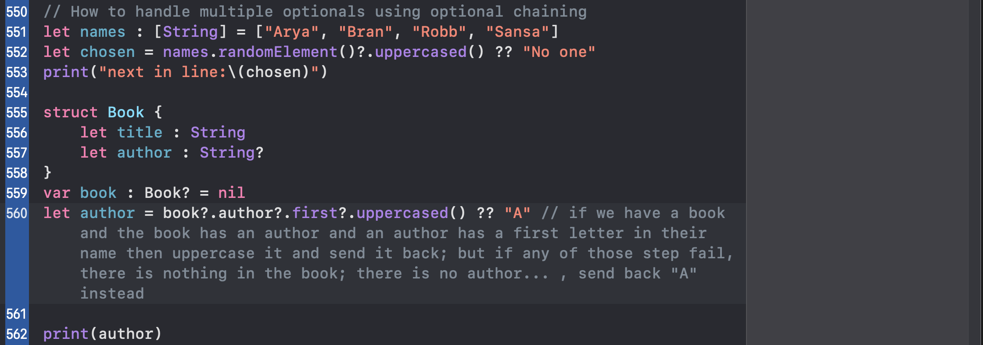

// How to handle function failure with optionals

You are going to find “try?” mainly used in three places:

* In combination with guard let to exit the current function, the current scope if the optional try call returns a nil
* In combination with nil coalescing to attempt something or provide a default value on failure
* When calling any throwing function without a return value; when you genuinely just don’t care if it worked or not

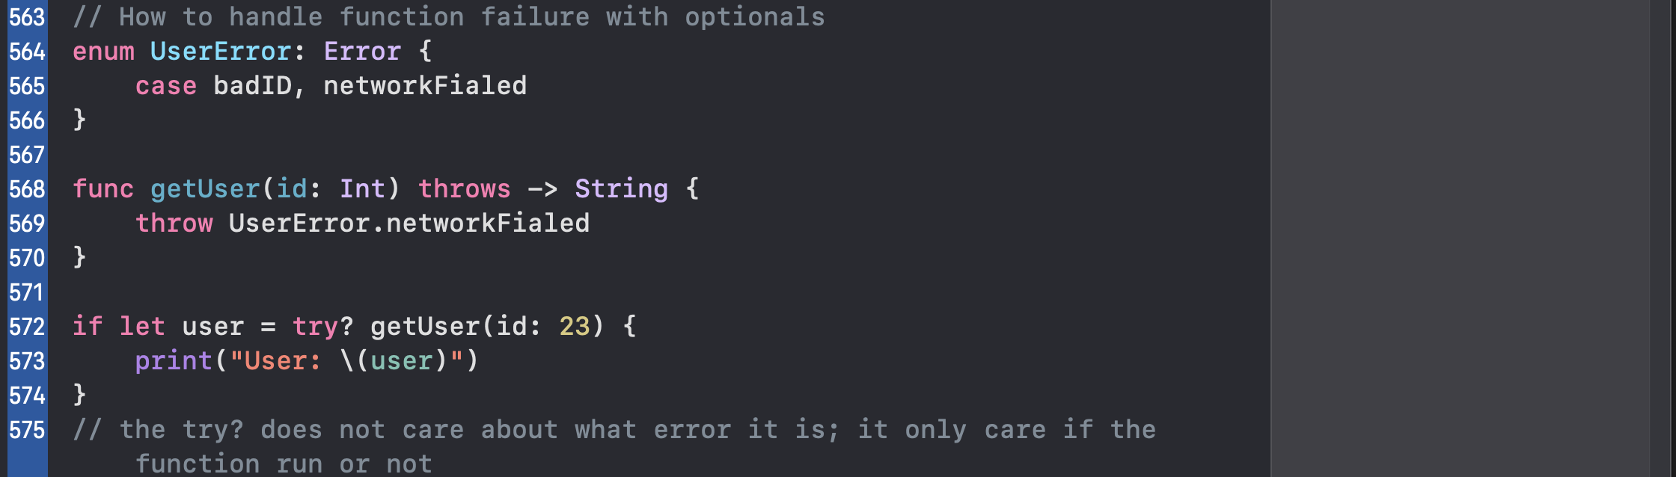

// Summary: Optionals

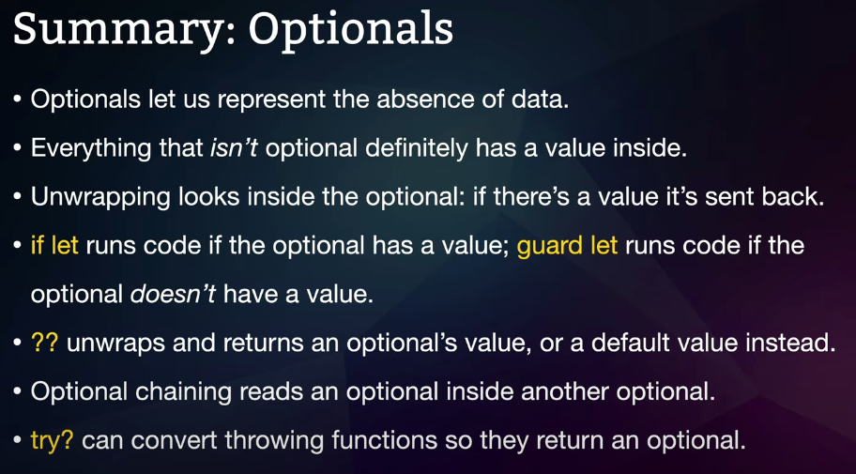

The some keyword was introduced in Swift 5.1 and is **used to define an Opaque Type**. An opaque type is a way to return a type without needing to provide details on the concrete type itself. It limits what callers need to know about the returned type, only exposing information about its protocol compliance.

// SwiftUI lessons

Creating a form:

Forms are scrolling lists of static views like text and images, but it can also contain interactive things, such as text fields, toggle switches, buttons, and more. Note: a form can have only 10 rows.

**Tip:** In case you were curious why 10 rows are allowed but 11 is not, this is a limitation in SwiftUI: it was coded to understand how to add one thing to a form, how to add two things to a form, how to add three things, four things, five things, and more, all the way up to 10, but not beyond – they needed to draw a line somewhere. This limit of 10 children inside a parent actually applies everywhere in SwiftUI.

If you wanted to have 11 things inside the form you should put some rows inside a **Group**:

Form {

Group {

Text("Hello, world!")

Text("Hello, world!")

Text("Hello, world!")

Text("Hello, world!")

Text("Hello, world!")

Text("Hello, world!")

}

Group {

Text("Hello, world!")

Text("Hello, world!")

Text("Hello, world!")

Text("Hello, world!")

Text("Hello, world!")

}

}

If you want your form to look different when splitting items into chunks, you should use the **Section** view instead. This splits your form into discrete visual groups, just like the Settings app does:

Form {

Section {

Text("Hello, world!")

}

Section {

Text("Hello, world!")

Text("Hello, world!")

}

}

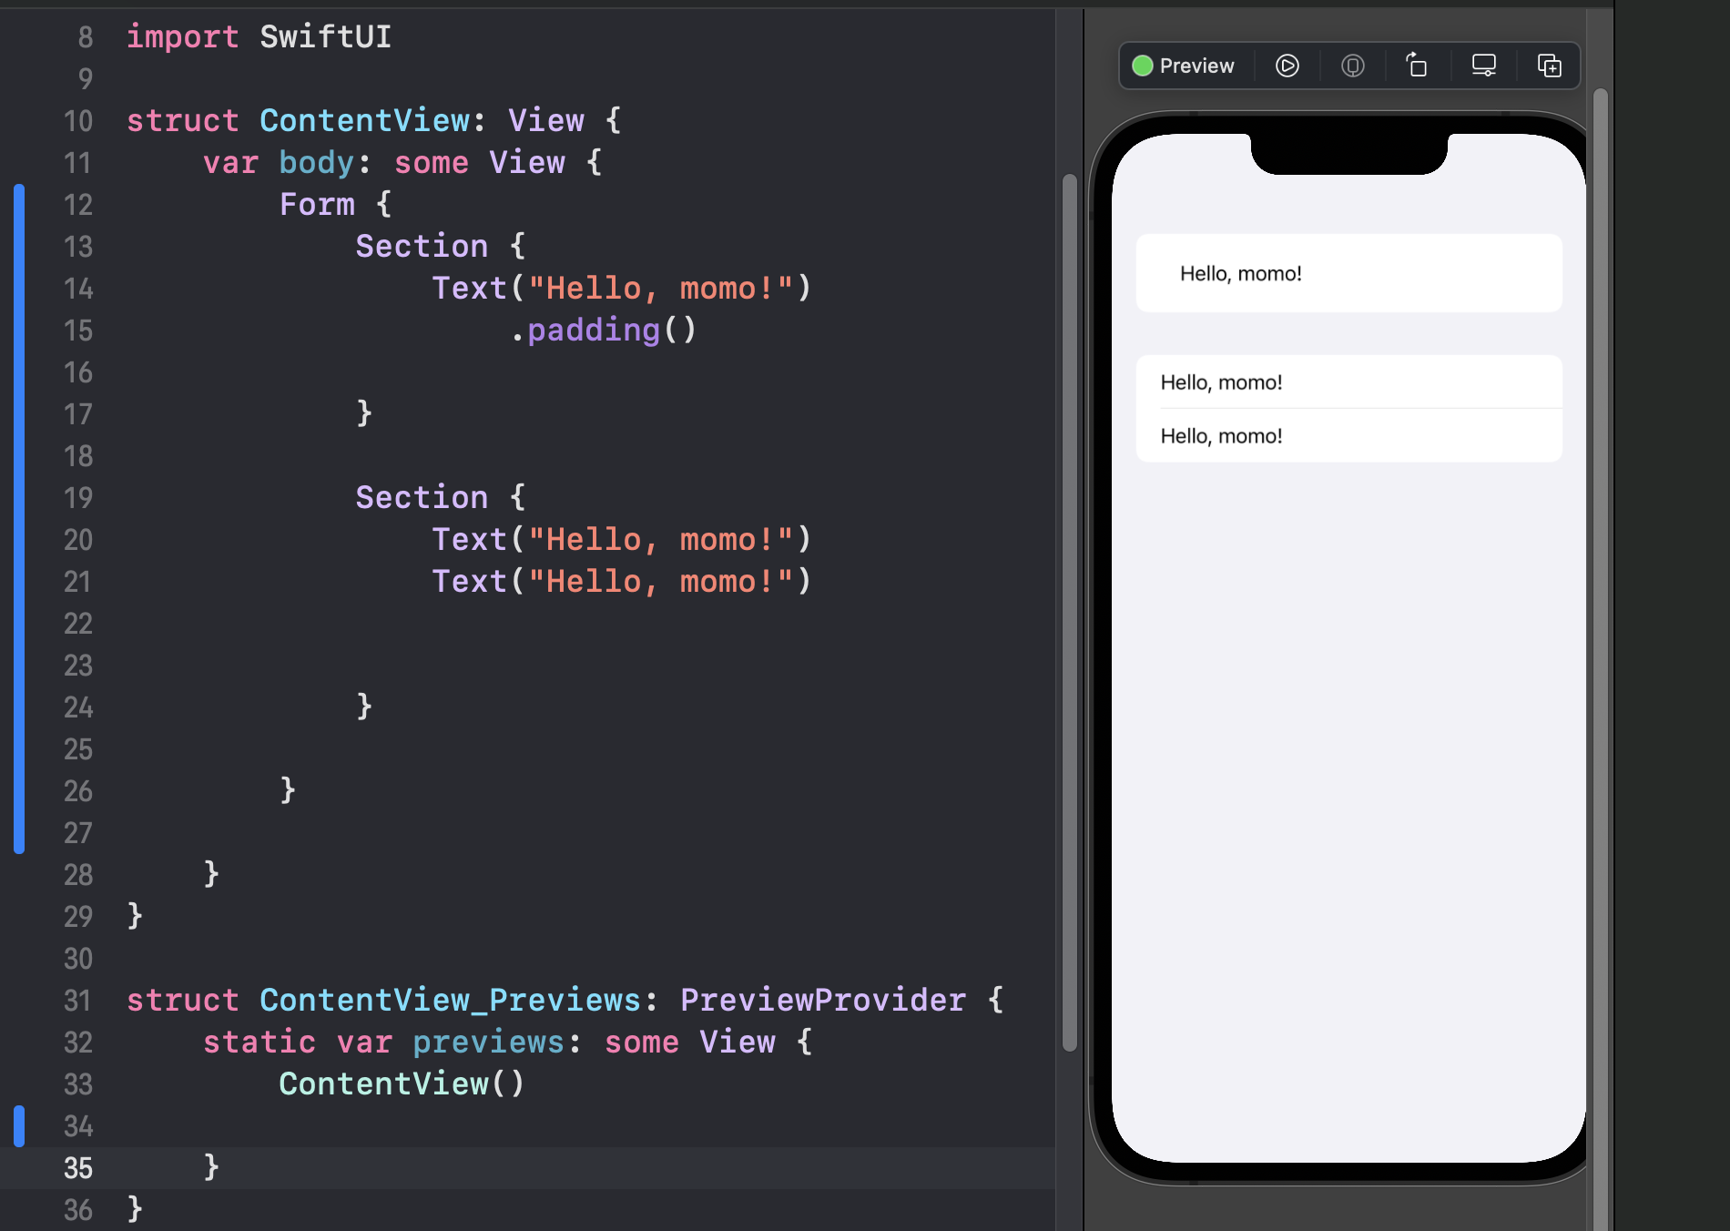

// Adding a navigation bar

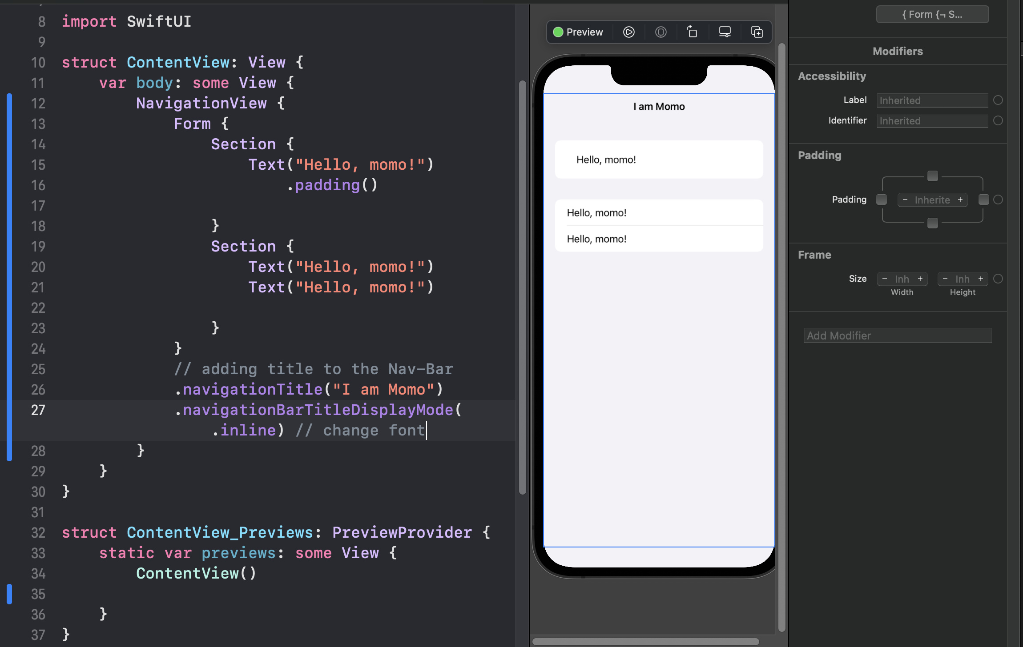

// Modifying program state

**@State** allows us to work around the limitation of structs: we know we can’t change their properties because structs are fixed, but **@State** allows that value to be stored separately by SwiftUI in a place that *can* be modified.

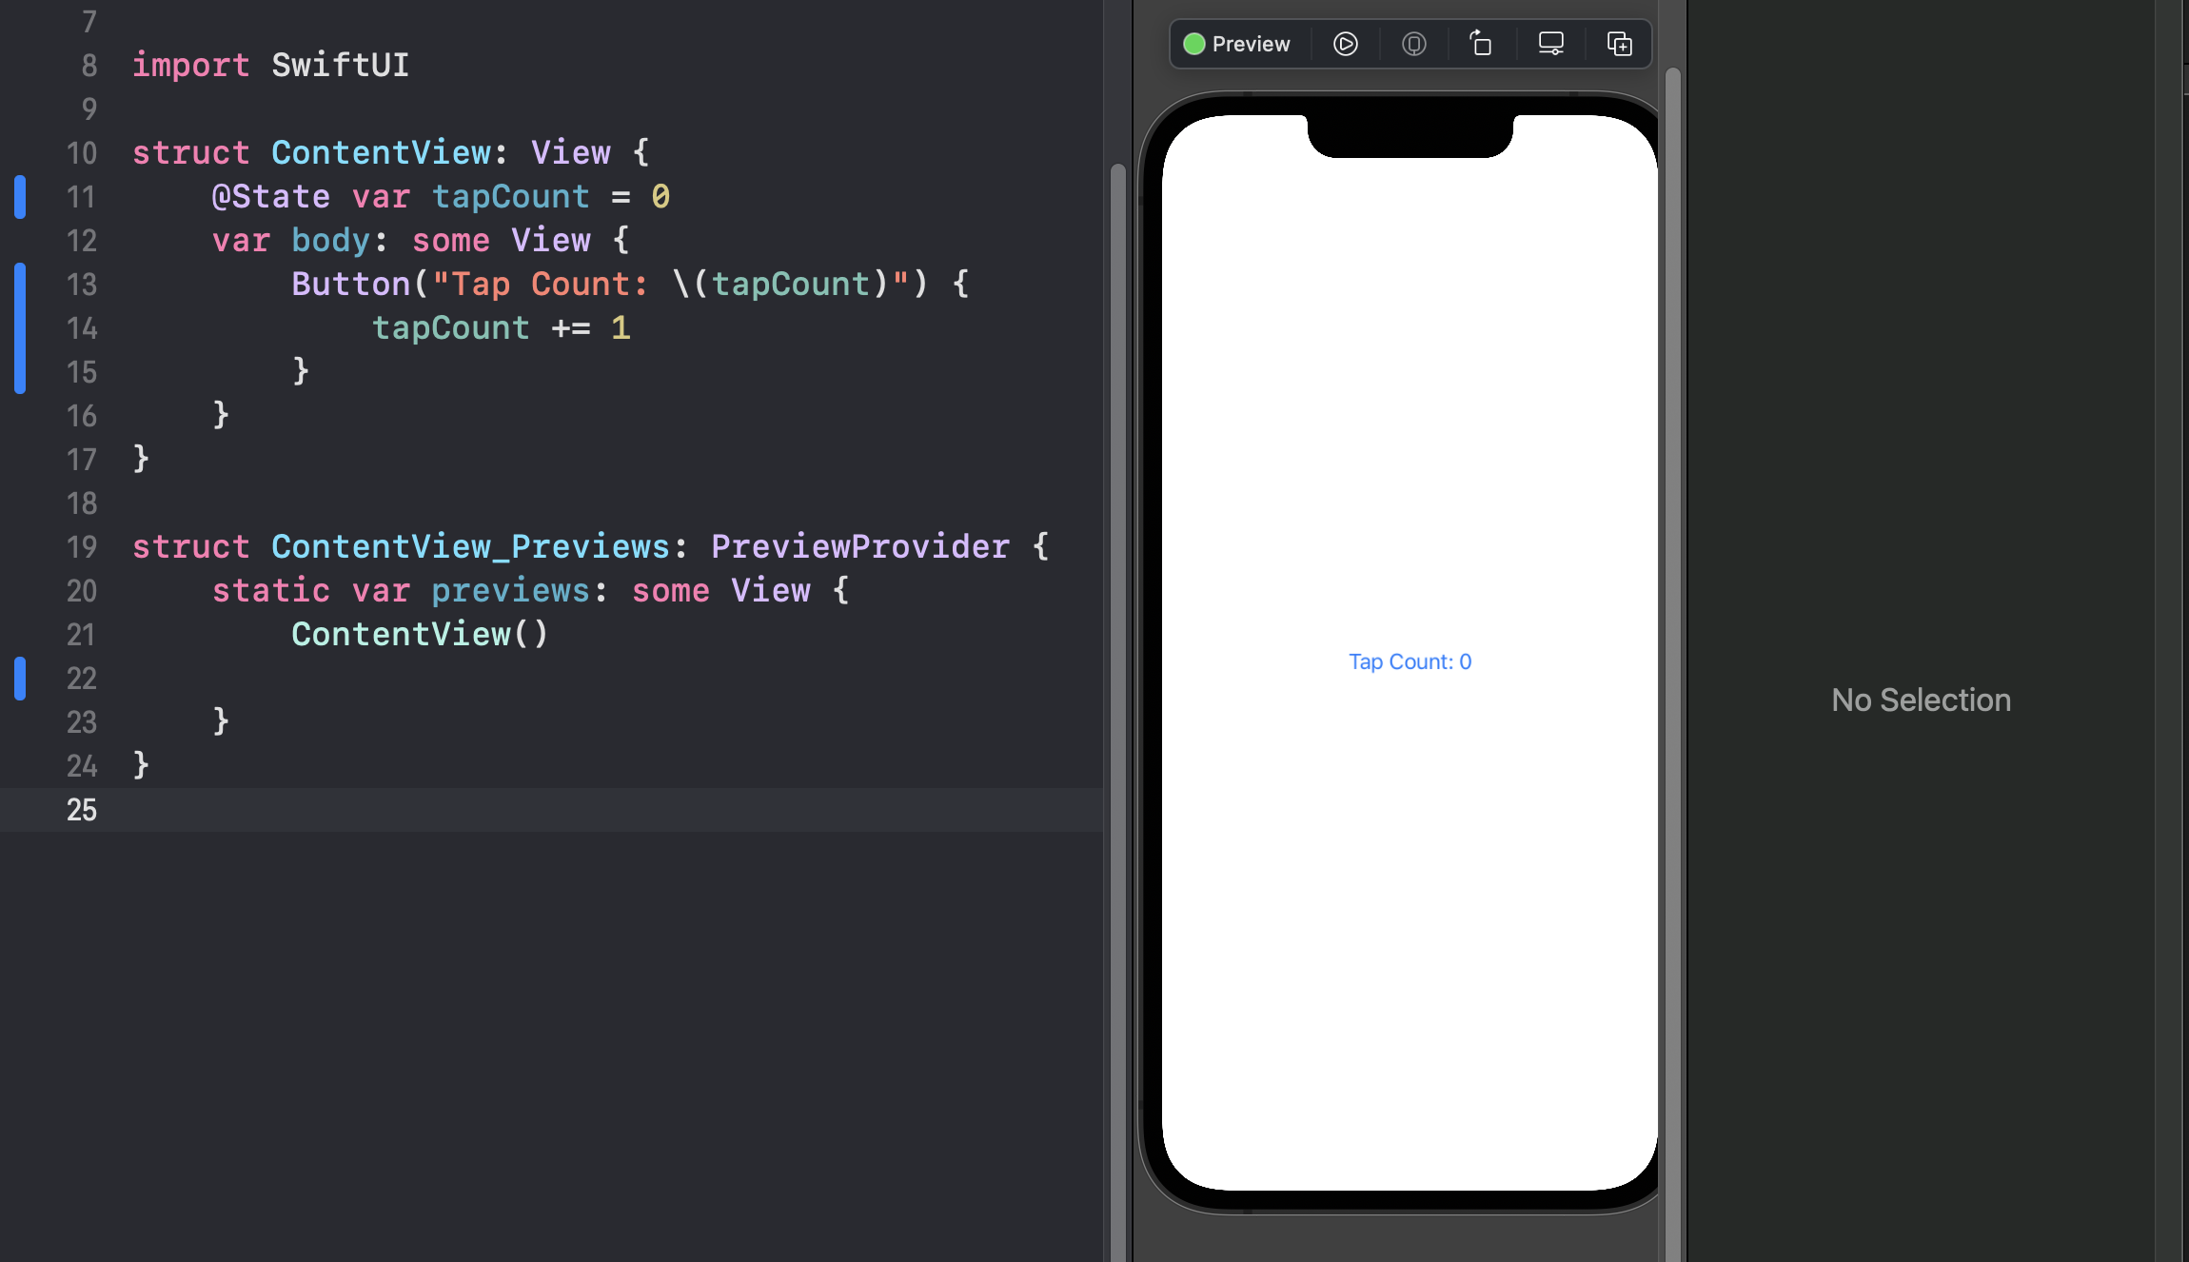

// Binding state to user interface controls

when you see a dollar sign before a property name, remember that it creates a two-way binding: the value of the property is read, but also written.

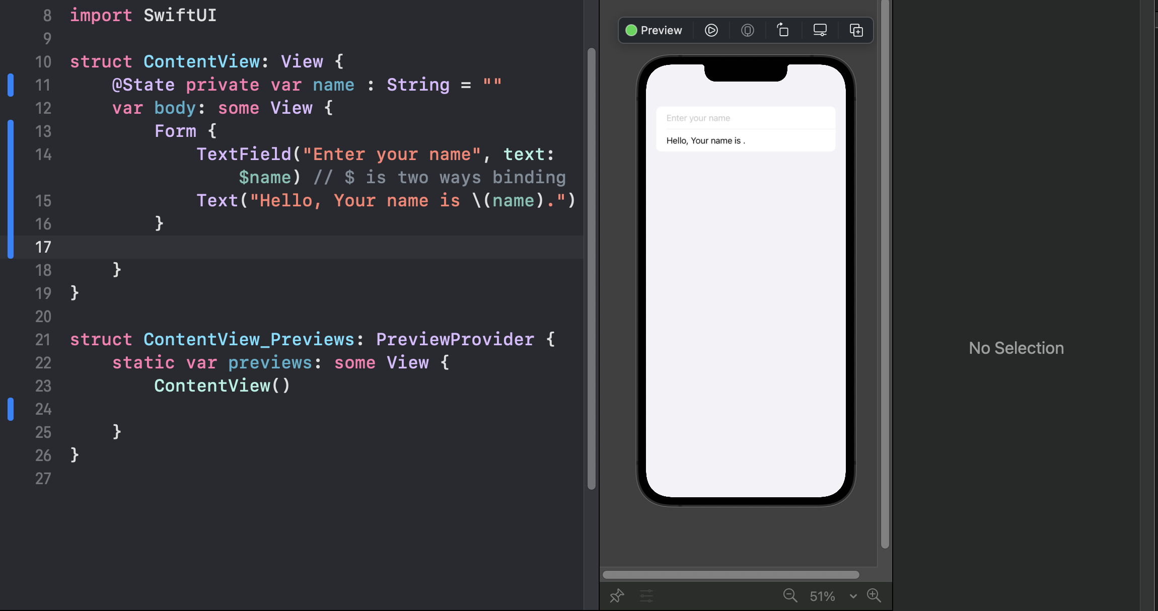

Where to learn Swift?

Teaching code

<https://www.apple.com/uk/education/k12/teaching-code/>

SwiftUI Tutorials

<https://developer.apple.com/tutorials/swiftui>

Swift documentation

<https://docs.swift.org/swift-book/>

hackingwithswift.com/career-guide

swift interview tips

bit.ly/sean-interview-tips